NEW RESEARCH
Introduction.
This latest version of Origins represents the compilation of our research into the history of our family to date (2023). Research however continues unabated as corrections are made or as new facts and details continue to emerge from the available records. This Addendum to Origins can be used to collate new information, but permission to circulate to the wider family rests with the individual researcher. As one piece of data generally provides new questions, leads and avenues for investigation, it would be advantageous to identify the source and date of the information to assist the efforts of future researchers.
As can be seen from our first Addendum story (due to the prodigious amount of investigative work carried out by Marjorie Winter), our family story now extends back to the mid-17th century and the origins of the names Bowman and Williamson as related to our Wilson line are much clearer.

THE BOWMAN and WILLIAMSON FAMILIES OF SCOTLAND
Records source: ScotlandsPeople, https://www.scotlandspeople.gov.uk/
by Marjorie Winter (2023).
The names Bowman and Williamson are linked to the Wilson family due to marriages in Scotland in the 18th and 19th centuries. The first of these was the marriage of Margaret Bowman to John Wilson in 1772 and then Margaret Williamson married William Hartley Wilson in 1820 (just prior to their coming to Australia). As was common in those times, many of the children of these marriages were given a specific Christian name (often in honour of the parents or siblings of the couple) and also a middle name to commemorate the spouse’s family name. For example, William and Margaret’s third son was named John (after his grandfather) Williamson (his father’s wife’s family name) Bowman (his grandmother’s family name) Wilson. This tradition has been perpetuated several times in the Wilson line, but the present-day holder of the name might well be unaware of its origin; this new research was aimed at overcoming this gap in our knowledge.
The Bowmans:
Alexander Bowman was born in Scotland in about 1690. He was contracted to marry Barbara Lowson on 16th of May, 1717 at Panbride, Angus:
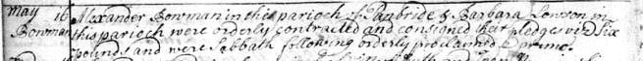
“May 16 - Alexander Bowman of the parish of Panbride & Barbara Lowson in this parish (Monikie) were orderly contracted and consigned their pledge vis six pounds and were Sabbath following orderly proclaimed.”
Alexander and Barbara were married on the 6th of June, 1717 in Monikie:
“June – Alexander Bowman & Barbara Lowson before named were married here having produced a testimonial of his being proclaimed at Panbride….last above named were married at….”
Alexander and Barbara had two sons:
David Bowman - was baptized 11 September, 1718 at Panbride, Angus. However, it is probable that David died before 1720 (although no death record has been found).
“September 11- Alexander Bowman & Barbara Lowson had their David baptized witnesses James Thomson & David Mill”….

David Bowman - was baptized 13th of October, 1720 in Dundee (it is assumed that this second son was also named David - a not uncommon practice in Scotland following the death of a sibling):

“October 13- Alexander Bowman & Barbara Lowson had their David baptized witnesses James Thomson & David Mill”.
David Bowman became a weaver. At age 26, he contracted to marry on the 25th July, 1746 & was married to 21-year-old Christian Spence on the 29th of August, 1746 in Dundee:
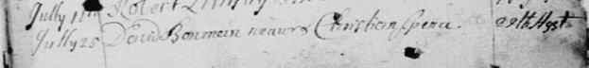
David’s wife Christian had been baptized on the 25th of July, 1725 in Dundee. Her parents were George Spence born on the 2nd of March, 1675 in Dundee and Christian Craig. Her siblings were: Agnes (born in 1709), George (1713), Barbara (1715), James (1716) and Elizabeth (1718). Her grandparents were: George Spence (born 1645) & Margaret Gourlay (Gowrlay). Their children were: Margaret (born 1671), Agnes (1672) and George (1675).

David and Christian had three children:
George Bowman – was baptized on the 10th of January, 1748 in Dundee. “Father’s occupation: weaver. Names noted George Spence grandfather, George Spence uncle”.
William Bowman – was baptized on the 26th of December, 1749 in Dundee. “Father: a weaver. Names noted at baptism William Bowman uncle + another William (surname illegible)”.
Margaret Bowman – was baptized on the 5th of March, 1751 in Dundee. “Father: flax reed maker. Names noted at baptism were Margaret Smith & Margaret Bowman, aunt”. Margaret was married on the 10th of November, 1772 in Dunnichen to John Wilson and bore him five children. She died in 1784, at age just 33 - possibly giving birth to her daughter Matilda who died in that same year. In 1786, John Wilson was re-married (to Margaret Ferrier).

While no death record was found for David Bowman, his wife Christian (Spence) was buried on the 31st of December, 1783 in Monifieth: “Christian Bowman from Dundee was interred here”.
Note – The marriage of Margaret Bowman and John Wilson in 1772 started our Wilson family line and it is now clearer where the names Bowman and Margaret (that were often repeated in the names of their progeny and descendants), had arisen. It is interesting to note that John Wilson and Margaret Bowman named their third daughter (born/died in 1784) Matilda – possibly after Margaret’s brother George’s wife, or her own nine-year-old cousin.
George Bowman became a sailor and, at age 23, married 23-year-old Matilda Anderson on the 18th of May, 1771 in Dundee – “George Bowman & Matilda Anderson clandestinely married in Edinburgh”.
The words ‘clandestinely married’ suggests some lack of approval by her parents – possibly because of his lowly occupation?
Matilda Anderson had been baptized on the 17th of February, 1748 in Newtyle, Angus. Her parents were James Anderson & Isabel Dickson; they were both born in 1720.
George and Matilda had ten children:
Alexander – was baptized on the 6th of September, 1772 in Dundee. “His father was a sailor. Names noted at baptism - Grandfather Alexander Anderson & Alexander Bowman - Great Uncle”.
George – was born on the 24th of October, 1773 and baptized on the 4th of November, 1773. “Father, George Bowman, shipmaster”. It appears he was no longer a humble sailor?
Matilda – was born on the 19th of February, 1775 and baptized on the 28th of February, 1775 in Dundee. “Father, George - a shipmaster”. Matilda was married on the 7th of January 1793 to David Patrick (born on 24th of April, 1771, c. 28th of April 1771 in Dundee). His parents were James Patrick (born in 1732), shipmaster and Margaret Wardroper (born in 1734). No children of this union were found.
David – was born on the 18th of March, 1776 and baptized on the 24th of March, 1776 in Dundee. “Father a shipmaster”.
Thomas – was born on 17th of March, 1777 and baptized on the 26th of March, 1777 in Dundee. “Father a shipmaster”.
James – was born on the 16th of July, 1778 and baptized on the 30th of July, 1778 in Dundee. “Father a shipmaster. Names noted at baptism - J. Brown uncle, James Bowman uncle + J Nicoll”.
Christian – was born on the 21th of August, 1780 and baptized on the 23rd of August, 1780 in Dundee. “Father a shipmaster”.
Elizabeth – was born on the 4th of July, 1782 and baptized on the 11th of July, 1782 in Dundee. “Father a shipmaster”.
Agnes – was born on the 28th of September, 1783 and baptized on the 28th of September, 1783 in Dundee. “Father a shipmaster”.
Isabell – was born on the 16th of July, 1785 and baptized on the 27thof July, 1785. “Father a shipmaster”.
George Bowman the shipmaster died and was buried on the 23rd of May, 1821 in Dundee.
Bowmans in Dundee.
Reference Source - “The Dundee Lockit Book, the role of the Burgesses of Dundee, 1513 – Present” (held in the Dundee City Archives).
ID No. | Year | First name | Trade | Privilege
426 | 1553 | George | - | *Simple Burgess
2624 | 1609 | Andrew | - | -
4487 | 1664 | - | - | Servant to John Wedderburn
4621 | 1668 | James | - | Servant to David Carhillis (Invergowie)
5041 | 1678 | Robert | Cordiner (shoemaker) | To his father
5058 | 1678 | John | Cordiner (shoemaker) | To his father
5772 | 1733 | Alexander | Apprentice to | John West, Walker
5954 | 1746 | David | Weaver and Reed-maker | Married to Christian Spence
6499 | 1781 | George | Shipmaster | Son of David Bowman, Weaver
6714 | 1795 | Robert | Merchant | Son of David Bowman, Weaver
7317 | 1818 | Thomas | - | -
8682 | 1902 | Private Alexander | - | -
* A Scottish burgess was any inhabitant of a burgh who held land there. The title was later restricted to merchants and craftsmen.

The Williamsons:
John Williamson was born in about 1745 in Angus, Forfarshire (his future spouse Margaret Greig was born in about the same year). John and Margaret were contracted to marry on the 27th of July 1771 and married in Kinnell, Angus on the 10th of August, 1771:
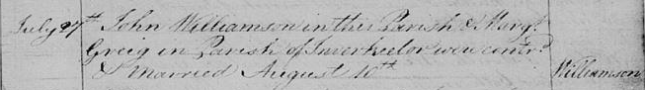
“July 27th -John Williamson in this parish & Margaret Greig in Parish of Inverkeilor were contracted & married August 10^{th”}.
Their son John Williamson was baptized on the 19th of May, 1775 in Arbroath:
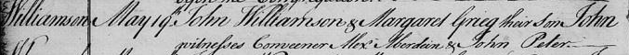
On their passing, both John and Margaret were interred in the Inverkeilor churchyard. A headstone was erected by their son John & his spouse Isabel (Dear), but there are no dates provided:
“Erected by John Williamson, manufacturer Arbroath and Isabel Dear his spouse in memory of his father and mother John Williamson and Marg Greig who are both interred here”.
Isabel Dear was born on the 20th of February, 1764 and baptized on the 22nd of February, 1764. Isabel’s parents were John Dear & Jannet Williamson; they were married on the 18th of June, 1756 in St. Vigeans church, Arbroath. They had 5 children: Robert (born 1759), Ann (born 1762), Isabel (born 1764), James (born 1766) and David (born 1769). All were baptized in Inverkeilor.
Isabel & John Williamson were married on the 11th of January, 1796 in Arbroath, Angus:
John was a merchant/manufacturer & hand loom weaver of “brown linen” that was woven from dressed flax. Brown linen was produced before the sun-bleaching stage whitened it. Forfarshire was a major producer of brown linen which in leaner times wove a loose fabric similar to burlap & hessian (which was in high demand).

John & Isabel Williamson had 8 children:
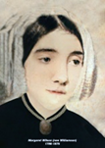
Margaret – was born on the 17th of November, 1796 and baptized 5 days later on the 22nd of November.
“Father - a merchant/manufacturer. Names noted at baptism Alexander Esplin & James Dear”.

It was Margaret Williamson who married William Hartley Wilson and sailed to Australia with him in 1820. Margaret died in 1775 in Tasmania.

Isabel - was born on the 8th of June, 1798:
She married James Sturrock (1791-?), a grocer & confectioner on the 6th of December, 1821. They had 7 children. James Williamson Sturrock, shipsmaster, (1822-1887). He married (1850) Euphemia Oliver. Ann Anderson Sturrock (unmarried) (1823-1864), Isabella Dear Sturrock (unmarried) (born 1824), Julia (unmarried) (born 1826), Margaret (unmarried) (1829-1881), Thomas (a solicitor) (1837-1916) married (1880) Mary Chesser (1852-1938) in Dalkeith, Midlothian, Catherine (Kate) (born 1841).
Isabel died on the 5th of April, 1866.

Mary – was born on the 10th of April, 1800 and baptized on the 17th of April in Arbroath, Angus. “Father-manufacturer. Names noted at baptism: Alexander Esplin & James Dear”.

John – was born on the 2nd of June, 1801 and baptized on the 14th of June in the Chapel of Ease, Arbroath, Angus. (John must have died before 1803 as there is another baby named John - but no burial record was found).
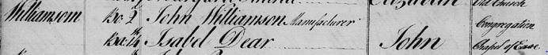
John - was born on the 4th of September, 1803 and baptized on the 25th of September 1803 in Arbroath, Angus. “Sponsors named at baptism: Jean Nicoll & Jean Leslie”:
Alexander - was born on the 13th of April, 1805 and baptized on the 27th of April in Arbroath, Angus. “Names noted at baptism were Jean Leslie & Margaret (Smith?)”:
Alexander died in 1837 & was buried on the 8th of March in Arbroath.

James - was born on the 2nd of June, 1806 and baptized on the 15th of June 1806 in front of the congregation, Arbroath, Angus.

Walter - was born on the 3rd of June 1808 and baptized on the 26th of June in Arbroath, Angus. “Names noted at baptism: George Morison & William Grudie”.
Their father, John Williamson, died at Green Street, Arbroath on the 24th of May, 1846 from “decline of old age – occupation manufacturer”. He was buried on the 28th of May, 1846, Row 23 in Arbroath Churchyard. His burial record says he has his own “stone” but none was found. No record of the death or burial of children’s mother, Isabel Williamson has been found.

The Ferrier Family
John Ferrier c. 8 September 1661 Brechin, Angus. Married 11 March 1686 in Dundee to Elizabeth Anderson b. about 1663.
They had one son: John Ferrier c.19 Apr 1691.Names noted at baptism John Smith & William Anderson. John was married 30 October 1717 in Barry, Angus to Isobel Thompson b. about 1692. John died in 1763 & was buried 17 July 1763 “John Ferrier, weaver, in ground of Carnoustie, was buried”.
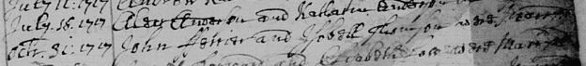
John & Isobel had 7 children.
- Anna Ferrier c.13 October 1718 in Barry.
- Thomas Ferrier b. about 1720. Spouse Janet Webster c. 23 December 1715 Monikie – father Robert Webster. Married “Contracted to marry 2 May, Jannet Webster & Thomas *Ferriar were married 3 June 1740”. *Ferrier is spelled in various ways on some records.
They had 8 children:
- John Ferrier c. 20 Feb 1741 Monifieth. Names noted at baptism John Webster, John Ferrier.
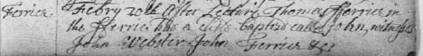
- Isobell Ferrier c.5 September 1742 Monifieth. She married William Anderson 20 December 1765 in Dundee.
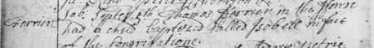
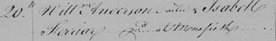
- Robert Ferrier c. 12 July 1744 Monifieth. Robert, sailor, married Isabell Thomson 17 March 1767 Dundee. Robert, shipmaster, died 11 July 1797 & buried in the “Old Burying Ground”. Their children were: *Margaret 1771, *Jean 1773-1785, married 1796 Robert Watson weaver, *Marjory 1775, married 1796 Robert Matthew, weaver, *Robert 1777.
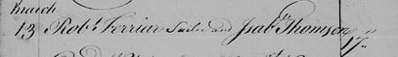
- Elizabeth Ferrier c 1 January 1746 Monifieth. Names noted at baptism: Walter Milne, Thomas Webster.
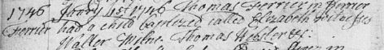
- Charles Ferrier C 29 January 1749 Monifieth.
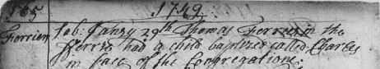
- Margaret Ferrier c. 24 June 1750 in Monifieth. Married 22 July 1786 to John Wilson in Monifieth. They had 2 children: James 1788-1794 & Isobell 1790-1792. Margaret was buried 12 April 1813 in Barry Churchyard.
- David Ferrier c 23 January 1752 Monifieth. Names noted at baptism: John Ferrier, Thomas Webster. Married in Monifieth on 11 November 1775 to Janet Webster 1778- 18 November 1829. David died 7 June 1829 age 77 yrs and his wife Janet died 18 November 1829 age 75 yrs. Children: *Jean 1786-1894, *Janet 1791-14 November 1829, *Thomas 1791- 7 Jan 1863, shipmaster, married 21 February 1837 Monifieth to Charlotte Frances Erskine Bisset 1816-1890 – children *Charlotte Frances 1839-1846, *Margaret 1839.Thomas erected a headstone to his father David & mother Jannet Webster, his sisters Janet & Jean, his daughter Charlotte & himself “At Beach Broughty Ferry, on the 7th instant Captain Thomas Ferrier”. *Margaret 1794-3 January 1872, single, a grocer, lived with her brother Thomas shipmaster.
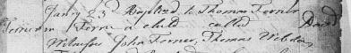
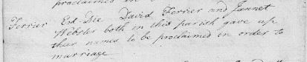
- Jean Ferrier c.26 June 1757 Monifieth. Married in Monifieth on the 16 January 1790 to Alexander Norrie c 25 September 1757- died 19 August 1813 in Dundee. His parents were Alexander Nory 1726 & Margaret Bell 1727 – they were married 17 April 1749 in Dundee. Siblings: Alexander 1752-1757, Jean 1754, David 1755, Ann 1759, Elizabeth 1762, Margaret 1765. Jean & Alexander Norrie had 2 children: Ann c. 6 Dec 1791, Alexander b.6 July 1793-c. 11 July 1793 – both children in Monifieth

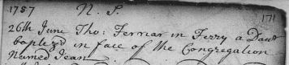
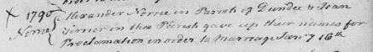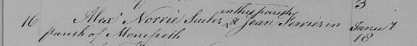
- Margaret Ferrier c 15 April 1721 in Barry, Angus. No marriage/death records found.
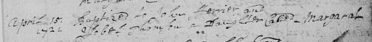
- Andrew Ferrier c 19 May 1723 Barry, Angus. He married on 7 July 1748 in Barry Margaret Finlayson b. abt 1723. They had 6 children: John 1749-1776, Anna 1751, Margaret 1755, Janet 1758, Isobel 1760, Barbara 1763.
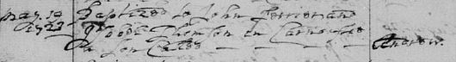
- John Ferrier c. 29 August 1725 Barry Angus. John, a weaver in Carnousty, married Margaret Espline on 24 August 1751 in Barry. No more records found for them.
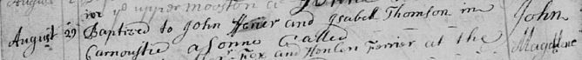
- Magdalene Ferrier c. 22 January 1727 Barry, Angus.
- Jean Ferrier c. 26 April 1731 Barry Angus.

