FEATURE | SKELTON | POLLY WOODSIDE | WINDEWARD BOUND | LADY NELSON
IMAGE | 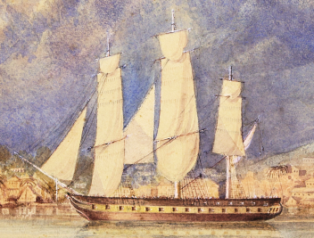 | 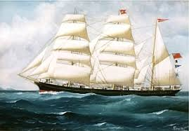 | 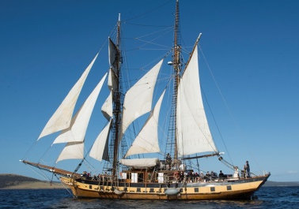 | 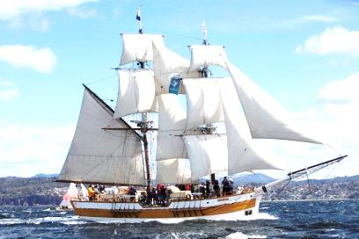
BUILT | WHITBY, UK, 1818 | BELFAST, UK, 1885 | HOBART, 1996 | TASMANIA, 1988
HULL CONSTRUCTION | WOOD, COPPER-SHEATHED | IRON | EUCALYPT, HUON PINE, & OREGON | BLUE GUM & CELERY TOP PINE
BUILDER | HOLT & RICHARDSON | WILLIAM WOODSIDE | THE WINDEWARD BOUND TRUST | TASMANIAN SAIL TRAINING ASSOCIATION
RIGGING | BARQUE | BARQUE | BRIGANTINE | BRIG
TONNAGE | 260/350 | 678 | 105 | 60
LENGTH | 86’ 6” | 192.2’ | 110’ | 52’6”
BEAM | 26’ 1” | 30.15’ | 24’ | 17’6”
DRAUGHT | 15’ | 14’ | 10’8” | ?
DECKS | 1¹/₂ | SINGLE | SINGLE | SINGLE
HEIGHT BETWEEN DECKS | 5’5” | ? | ? | ?
MASTS | 3 | 3 | 2 | 2
MAINMAST HEIGHT | ? | 108’ | 85’ | 52’
GUNS | 2 | NONE | NONE | NONE
FATE | SANK, ANGUILLA ISLAND 1828 | MUSEUM SHIP | CRUISE/TRAINING SHIP | CRUISE/TRAINING SHIP

With extra deck added?

