Image C-045B William Wilson – Colonial Architect & Superintendant of Stonemasons

Two early constructions which are attributed to Bonnie William’s as Colonial Architect of Van Diemen’s Land both completed in 1824 and still in use today – the original Scots Church, now St Andrew’s Hall and Church Administration Office in Bathurst Street, and the original Supreme Court building in Macquarie Street, now part of the State Treasury complex.

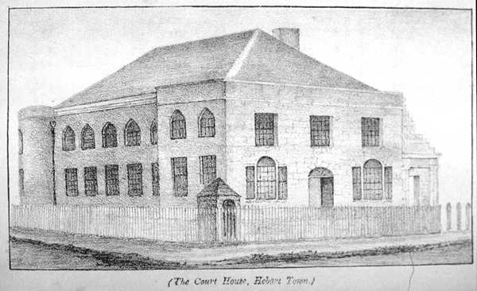
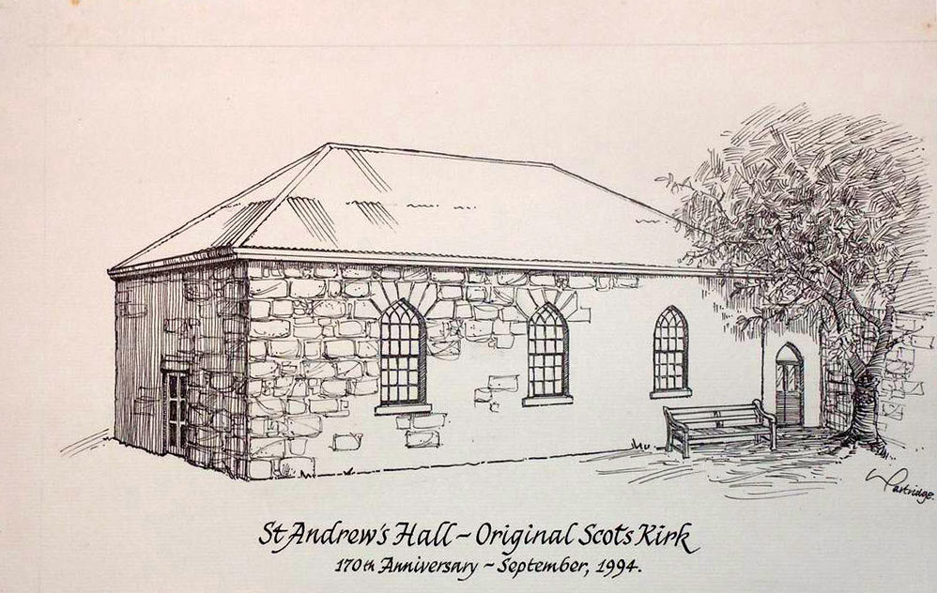

This further sketch recorded as 1838 of the Supreme Court House also shows what was a substantial VDL Police Department Headquarters which has been added by then a little further down Murray Street. William was not responsible for this building – it would have been the then Colonial Engineer & Architect John Lee Archer. But it is obvious that the Police building design followed very closely that created by William for the Courthouse. The 1824 Courthouse became the State Treasury building in 1888 when a new Supreme Court building was built further away from the Murray Street government buildings, no doubt emphasising the ‘Separation of Powers’ principle. The Police building was demolished when new Government offices were erected during the 1970s. Opposite where the Police building is seen here are further Government offices dated to the 1960s for which the Architect was William’s Great Grandson, David Hartley Wilson.
