Selected Notes on our Wilsons and the Tuerong Park Pre-emptive Right
Some early history, and, ongoing Mystery
William Thomas was appointed an Assistant Protector of Aborigines in Victoria from 1839 to 1849 for the region around Melbourne including the Westernport region. His son William Jackson Thomas was granted a 12000 acre licence for Tuerong Station on Westernport (the original aboriginal words for the country said to be Teworing, on the Checkinkurk Creek). Thomas Jr established a homestead on what later became the site of the Tuerong Pre-emptive Right (TPPR), which our Wilsons later owned: today the site of Dromana Estate.

Thomas Snr mapped much of the Port Phillip and Westernport Bay regions (he names the latter Weston Port on his map): his map is shown here, showing where he marked the locations of a Protectorate hut he erected on the original Tuerong Station property beside the Tubbarubbabel Creek. He lived and journeyed out from this aboriginal protectorate/encampment as he pursued his protectorate role, and undertook his mapping work. He also had Protectorate huts in the Narre Warren, and Merri Creek areas around Melbourne. Sometime in the 1850s he resided permanently near the Merri Creek/Yarra conjunction.

Thomas’ survey map co-ordinates for Thomas Jr’s TPPR hut location are 38°17.5′S, 145°4′E, and today’s Google Earth Satellite co-ordinates of 38°17′S, 145°4′E for Dromana Estate attest to his precision. The Protectorate hut was about 3km south of TPPR. Thomas Snr’s wife later lived apart from Thomas in another hut/home about 0.5km south east of Thomas Jnr’s TPPR.
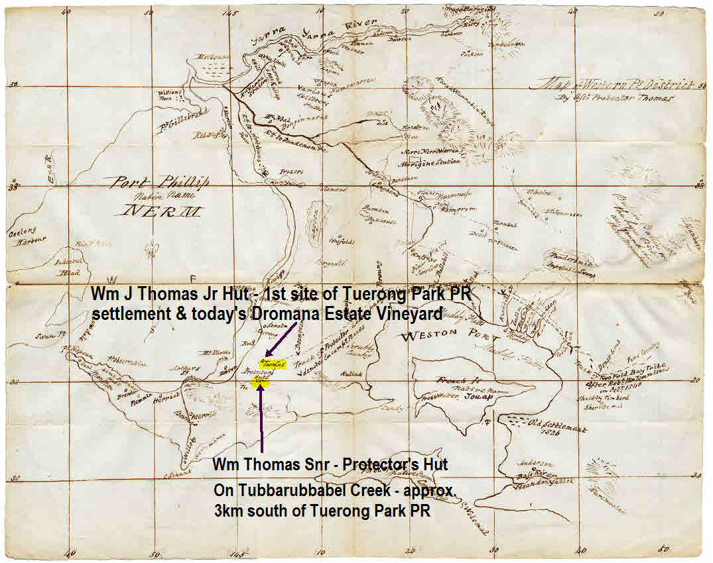
The Tuerong Park Pre-emptive Right (TPPR), was a one square mile component from the 12000 acre Tuerong Station. This is where our Wilsons would have lived and farmed from the time they acquired the property in the second half of the 1860s: initially John Bowman Wilson, Agnes Eliza and their children. Later, John’s brother William Sorell Wilson become financially and operationally involved with the TPPR property as well. Tuerong Run was divided about 1860 by Government decree into 640 acre lots and the TPPR lot was initially bought by Ralph Ruddell for £1 per acre. There appear to have been other owners also prior to acquisition by the Wilson family. (See appended excerpt from Hastings Shire Historical records)
This map shows the Runs around Port Phillip and Westernport districts from 1835, the Tuerong Run highlighted in green. William Sorell Wilson initially worked for ‘Big’ Clarke, then until ca.1867 leased farmland from him near Truganina, selling it following a dispute with his co-lessee.
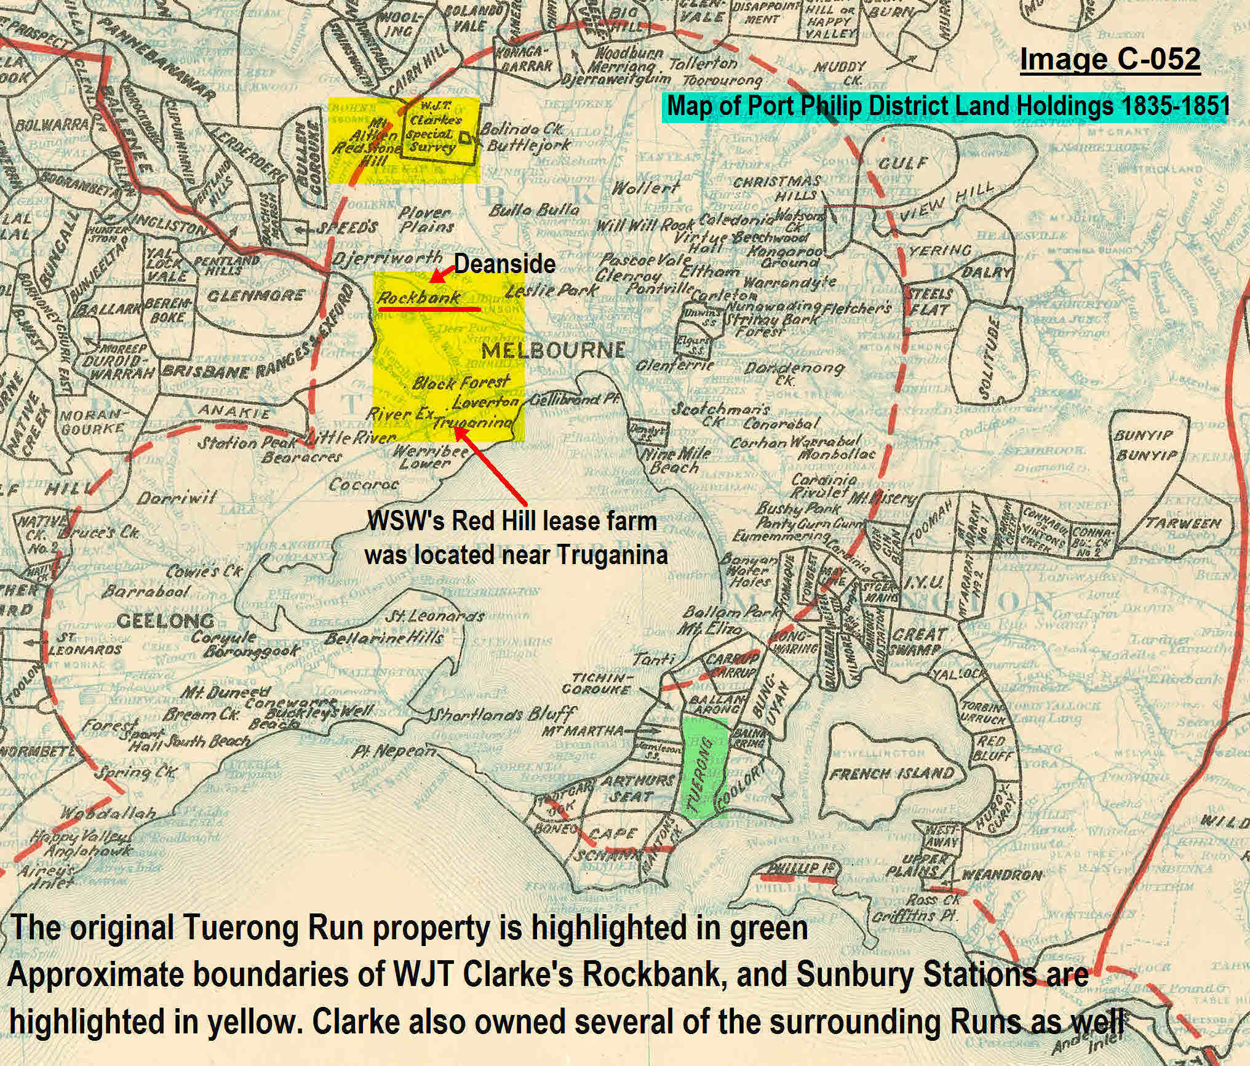
The map below ca.1860s shows the TPPR property of 640 acres – purchased by John Bowman (with his mother-in-law’s financial assistance), presumably from the Ruddell family or its mortgagor. It spans over Tuerong Junction. The left side (west) red marker locates the homestead location of Thomas Jr/Ruddell/John Bowman, where we are lunching today. The right marker (east) was a much later (ca.1900) homestead established after the 640 acres was further sub-divided – that homestead was at one time called Tuerong but later renamed Hadlow. The Ward homestead location of Peter Ward’s family is the green marker. The adjoining 10D plot was owned by Shirley Davies’ great-grandmother, Emily Matilda Wilson nee Horton, acquired with a Horton family inheritance. Lot 10C belonged to the Sonnenberg family whose daughter Elizabeth was to marry John & Agnes Eliza’s son Arthur.

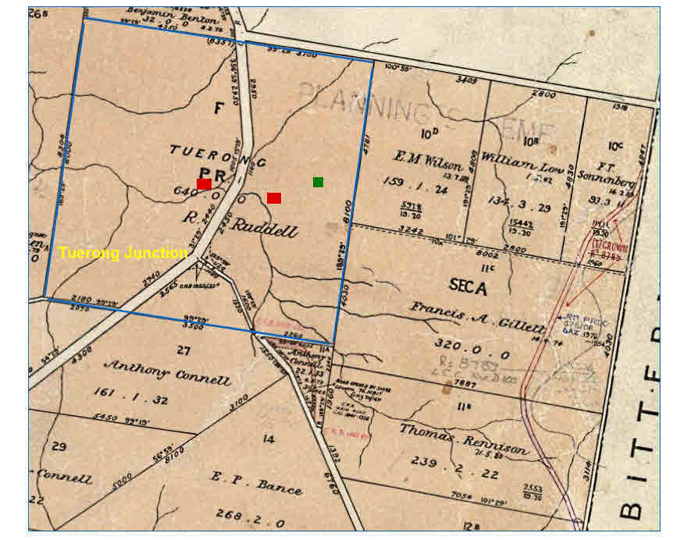
More Location Maps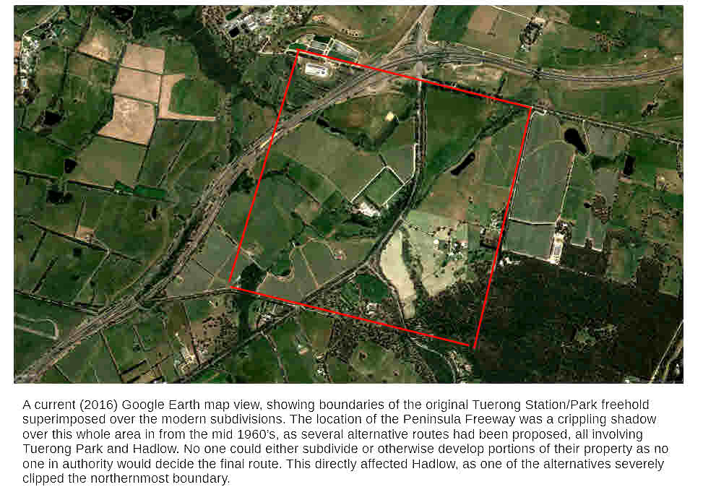

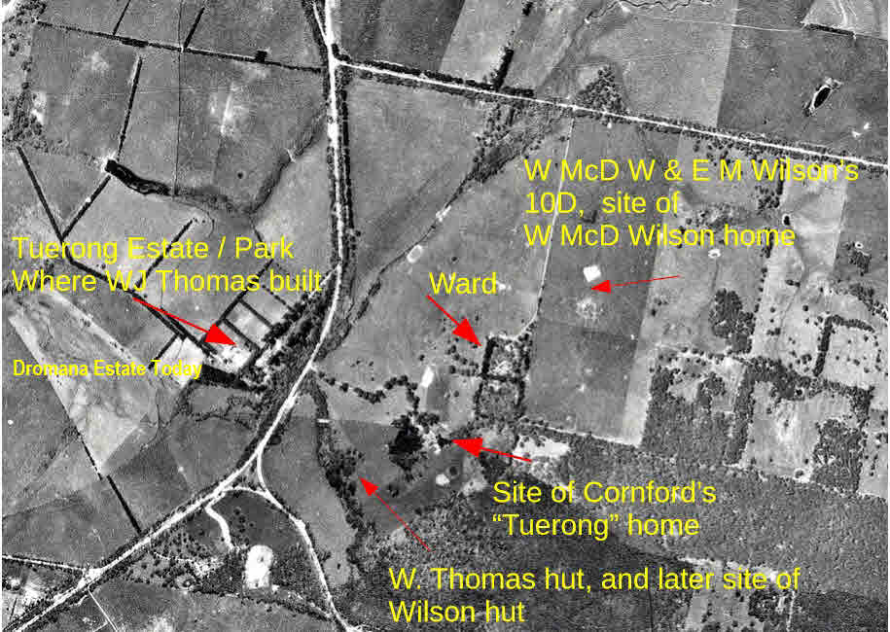

The Mystery of the Disappearing Buildings

Dromana Estate Winery today - but, do any buildings on the site today date from our Wilsons’ Era
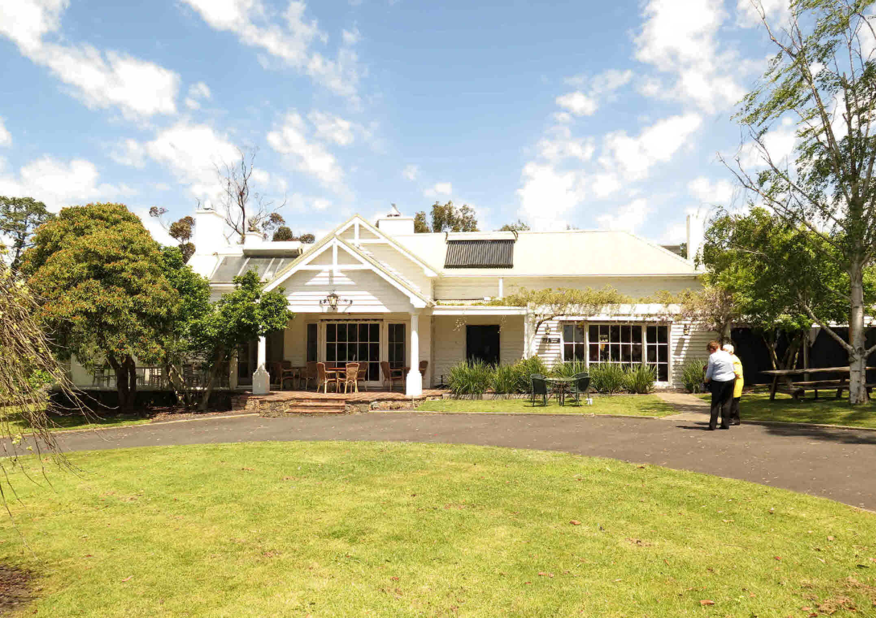
Dromana Estate Winery is positioned precisely on the homestead site of the Tuerong Park Pre-Emptive Right farm homestead established by the Thomas family: our Wilsons, John Bowman & Agnes Eliza, and children would initially have lived in the homestead on this site from about 1865. But the mounting evidence is that the original homestead buildings for reasons unknown appear to have ‘disappeared’ sometime prior to 1879. Peter Ward’s research has identified a succession of records/maps which show as early as 1855 a four room cottage with several farm buildings, later in 1861 both a four room cottage as well as a nine room homestead, plus farm labourers’ accommodation, a dairy and an array of other farm sheds and buildings.

This 1855 official survey map shows the various homestead and farm buildings on the TPPR site.
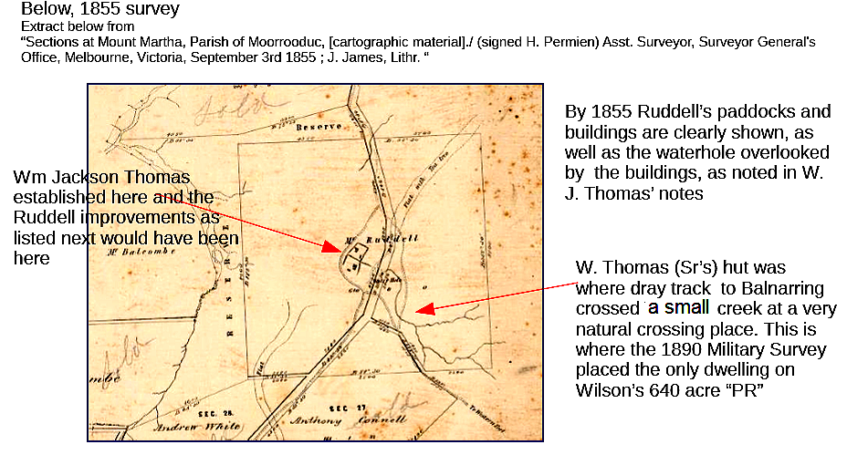

1855 Survey Map Enlarged: highlights buildings on the TPPR, but not Mrs Thomas’ hut 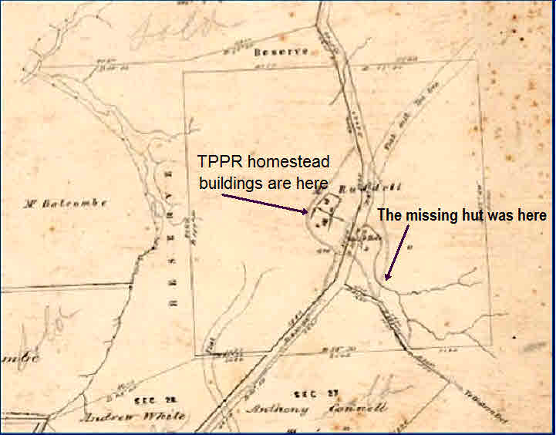

But why is Mrs Thomas hut not here, where years later John Bowman is said to have died
Quoting from Peter Ward’s paper “From May 16 1840 William Thomas was living at Tubberubbabel, his wife in a hut at Tuerong, and William Jackson Thomas also had huts at Tuerong. On 19 Jul 1840 the Tubberubbabel aboriginals had encamped at Tuerong, one of their regular movements. By Sept 5, tribes had moved to Melbourne, and the Peninsula Protectorate ended. Thomas’ wife’s hut was separate from William Jackson Thomas’ home, and was sometime associated with an encampment.”

Other researchers have reported that Mrs Thomas hut (at Tuerong East) was made of bark cut for her by the local aborigines, who often camped nearby and received provisions from her. They report also that Wm Thomas Jr’s hut at Tuerong Park (West) was finished with a reed roof rather than bark.

[From Hastings District Heritage Study ‘The license for Tuerong Station, where William Thomas, the Assistant Protector of Aborigines was centred, was held by his twenty-year old son, William Jackson Thomas. In September 1842 the license passed to George Bolton Eagle, and in September 1846 it transferred to William Dawson. In July 1849 John McKenzie and Joseph Hall secured the lease of the station, holding it for less than a year. In February 1850 the leaseholder was John Miller and in May 1852 Tuerong passed to Ralph Ruddell. Ruddell was followed by Vaughan and Wild, whose lease operated from April 1860 to August 1864, when it was cancelled.’]

The 1855 survey does not show a hut where Mrs Thomas had been living, such as later appears on the 1891 survey map (below), most likely she (and all the Thomas family) had long since moved to the Merri Creek site. Possibly by 1855 Mrs Thomas’ hut had been destroyed in bushfire or was otherwise lost. One of the most devastating bushfires ever experienced in Victoria occurred in 1851 when over 5 million acres (one third of the State) was destroyed, the Westernport district amongst the worst affected. Our colleague Shirley Davies’ family lost several of their McClelland forebears, a mother and five young children, in horrendous circumstances in this fire, in the Plenty River region.
In 1868 a Mortgagee sale notice for the TPPR states only 640 acres of freehold land for auction with no improvements – unusual indeed. But by 1879 in an advertisement for sale by assignees of an insolvent Mr J B Wilson, improvements are described only as a four room cottage with no mention of the earlier nine room homestead or of farm buildings, whilst by 1888 on ultimate sale of the property by J B Wilson trustees (to William Sorell and Edwin), there are no on site improvements recorded in the published sale advertisement.

Later again in 1891 a Military survey map (produced to have our forebears prepared for war because ‘the Russians are coming”!) shows only a four room cottage but now over on the east side of Old Moorooduc Road (called three chain road then). This is where Mrs Thomas’ hut had been. John Bowman Wilson died at Tuerong in 1893 so it appears this must be the house where he spent his last days.

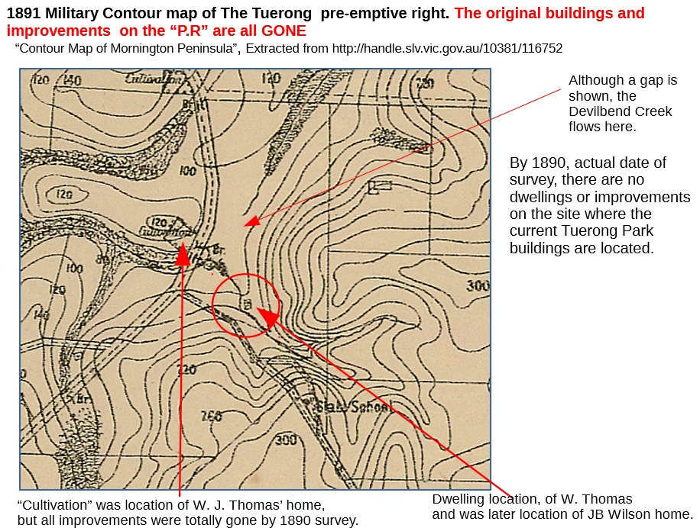

TUERONG PARK - Heritage Council Victoria’s Inventory Description
The site comprises the Tuerong Park homestead, garden and associated shearing shed and dairy. It may also have been the site of a hut built by the Assistant Protector of Aborigines William Thomas in 1839.
Heritage Inventory Significance: The site is significant to the Mornington Shire as an example of landscape design from the 1920-30's. The remains of the wattle and daub hut in the homestead would have State significance if they were those of the Protector's hut.
Heritage Inventory Key Components: Tuerong Park Homestead, attached pergolas and paved terraces and stair, weeping elm, and conifer stumps. The remains of a wattle and daub hut were uncovered by a former owner while renovating the kitchen of the homestead. Two farm sheds also nearby. Heritage Inventory Site Features: House - Tuerong Park Homestead, Weeping Elm - on drive approaching homestead, Pergolas - north and east sides of house, Stone Terrace and stair - east side of house, Conifer Stumps - approximate locations only, Dairy and paved yards behind, Shearing Shed.

An image of the bark hut where Mrs Wm Thomas resided early 1840s on the eastern side of the 640 acre property is seen below – in either this hut, or more likely in another built later on the site, John Bowman passed on in 1893. By then the TPPR farm, was financed and operated by William Sorell and John Bowman’s son Edwin: probably a share-farming arrangement. A Transfer of Land deed dated 1888 records the event.

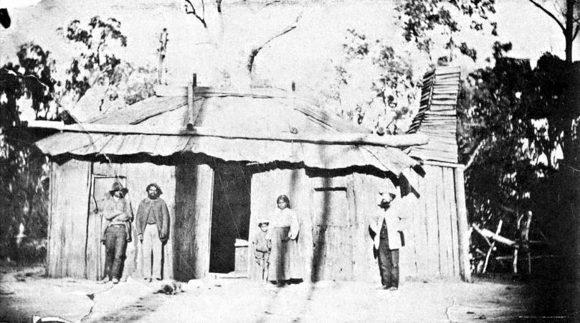

How to explain the disappearance of the large number of homestead and farm buildings
Only two explanations for the disappearance seem to offer – either they were lost in a devastating bushfire, and/or, they were sold/relocated to other farms in the region – perhaps to those of the children of John & Agnes Eliza as they set up their own family homesteads/farms which most of them did, or to members of the William Sorell family’s extensive array of farm properties in the Bittern/Hastings/Balnarring regions. Of these explanations bushfire seems the more likely, however extensive research by Peter Ward has so far not identified such an event. Peter Ward’s research tells us many farm buildings were lost in a 25000 acre fire which swept through the area in 1905.

The shed in the image below on the Dromana Estate site today, is Heritage listed and may have been an accommodation hut of a later era, perhaps early 20th century. In that era it was normal for the residence to be separate from the kitchen for fire safety reasons. The emerging evidence suggests that for whatever reason, the original homestead (huts) and farm buildings, progressively established by Wm Thomas and his son and successive owners, were lost, and the Dromana Estate buildings we see today were erected post 1891. Still, here we are lunching today where our forebears lunched many times from over 150 years ago.
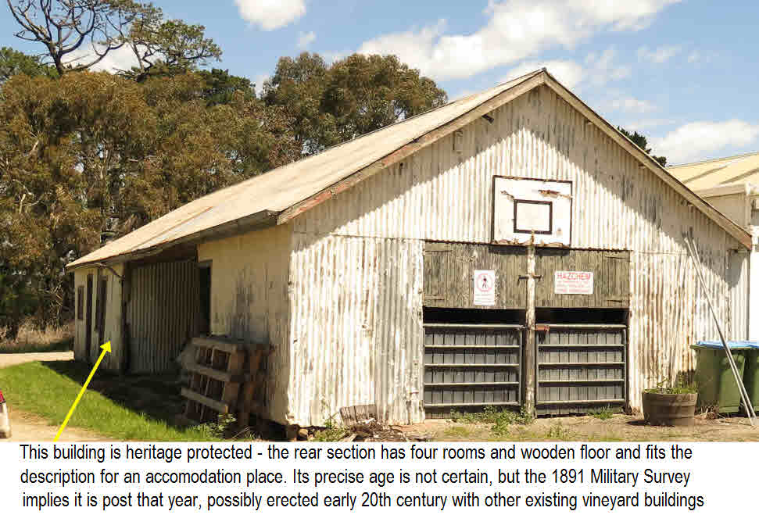

Selected excerpts from Peter Ward’s Tuerong Park research paper
[Peter’s full set of research documents may be perused via our website at www.bonniewilliam.com and it makes fascinating reading]

The Wilson property was listed at the first insolvency sale attempt (Aug 1879) as still of 640 acres, and with only a four room cottage mentioned, which was on the western side of the divided property. The property obviously was not sold, and operated under Trustees until the final Trustees auction. Trustees for J.B. Wilson listed the 640 acres again in 1888 as a Trustee’s Sale. The 170 acres had not been excised, nor was any residence mentioned, as you would expect of such magnificance. This leaves the conclusion that the subdivision was either part of the settlement activities of the Trustees in 1888, or later. The gentleman’s residence at “Tuerong”, later “Hadlow” was built after Wilson tenure.
(The original “Tuerong Park” homestead I used to visit in the 1950’s had obvious signs of its heritage everywhere. The area within the back door looked original (with its huge hardwood “stump” butchering block, whilst the front and living room of much later build. I believe this part had been attached to the main building in more recent times, having been the “detached kitchen” described in the1852 advertisements.)
Thomas 1839 – built a comfortable hut and another small hut for the men (employees).
Aug 1849. Tuerong Station for sale, owner not indicated A good “three room hut”. The Argus, Mon 20 Aug 1849
1853. Tuerong Station for sale again, or possibly it had not sold when advertised previously. Owner not indicated. Carrying 400 head. Now the house has four large rooms Multiple adv., Argus 3 -20 Dec 1852 3 - Jan 1853
Aug 1879 J.B.W Insolvency sale. A four room cottage on the 640 acres. Age 23 Aug 1879
Interestingly, the E.M. Wilson “grand farm” (Lot 10D) is advertised with a four room dwelling, sheds, stables, and 10 ac. orchard, none of which were in the slightest bit evident to this author who spent so much time hunting, ploughing, and doing improvements on this block. Only the tiny pieces of pottery and the marble by an old Cyprus I referred to earlier would pinpoint the home location. The Mornington Standard reported on a great 25,000 acre fire in Jan 1905 in this area, which could account for the disappearance of every trace of what appears to be a small but complete farming operation. Details of that fire are attached as an appendix. This block would have represented a huge challenge to farm in the 1880’s.
Poor soil, lack of permanent water and difficult access in winter. My hat goes off to Edwin Wilson, and also to Arthur if he was farming the Sonnenberg block just up the road. (It seems EM Wilson** was JBW’s brother’s wife. I am at this time, just assuming that Edwin worked here)
**[Insert Note from Shirley Davies re who the E M Wilson was –
Yes, it was my great-grandmother, wife of William McDonald Wilson - EMILY MATILDA WILSON NEE HORTON. i think William McDonald Wilson got into financial difficulties and as his wife had an inheritance from her parents, William Peters and Mary Ann Horton (they lived at Mornington), in order to have the family still live on the property she bought it and had it in her name. I know that some historians had recorded it in a male's name but this was not so. From memory they found a male Wilson with the initials E.M. who lived at Rosebud or Sorrento and thought they had the right person. I don't think many women had properties in their sole name at the time. I remember growing up and my grandmother Emily May Perrott nee Wilson saying that it was her mother who had the money and owned the property - also she owned the house they later lived in at Hastings.]

Wilson family, take part in the Tubba Rubba gold Venture. Including J.B and E. Age, 1 Jun 1888
Arthur Wilson, who married F. Sonnenberg’s daughter, held road maintenance contracts. F Sonnenberg also was a contractor to Mornington Shire. Mornington Standard, 7 Nov 1893
Mar 1893 John Bowman Wilson dies on Tuerong Station Leader 18 Feb 1893
Jun1893 Reports of gold on Gillette’s. Albert Wilson mentioned The Age 14 Jun 1893
Jan 1894 Agnes Wilson passes. Has left “Tuerong Station” and moved to Mornington Hobart Mercury 27 Jan 1894
Nov 1895 Wilson’s Bridge! But still Cornford to the East, Crooks to the West. Mornington Std 7 Nov 1895 .
E M Wilson block being sold. NO MENTION of the home and shedding of the earlier advertisements 16 Sept 1911 Mornington Standard
MR. H. WILSON. The death occurred at Mount Martha on June 2 of Mr. Herbert Wilson aged 66 years. The deceased had been in indifferent health for some time, but the end came unexpectedly. He was the youngest son of the late John Bowman and Agnes Wilson, who were pioneers of the Mornington district, arriving from Keilor Plains in 1863. His parents settled at Tuerong, where he was born. The deceased accepted managership for Sir Geo. Fairbairn about 30 years ago, and at his death, was still in Sir George's employ. He was highly respected, by all sections of the community. His splendid work was responsible 'for "Greenlaw", being developed into a model farm, carrying a fine flock of Suffolk sheep, fat and dairying cattle. Stock from this property, when yarded at Tanti always brought high prices. At the Sheepbreeders' Show Sir George Fairbairn's Suffolks have gained many awards, the judges commending the excellent quality of the exhibits. Mr. Wilson was one of the first to realise the advantages to be derived from subterranean and other clovers on Peninsula farms, and was also a keen advocate of top-dressing pastoral lands with superphosphate. In his young days he took an active interest in the Mornington Town Band and was one of its foundation members. He was also associated with the Military Rangers. It was then a unit which held Easter encampments at Langwarrin. He was a good cyclist, and on one occasion won a gold medal for a championship event staged on the old picnic park track. The late Mr. Wilson was one of the first persons to own a bicycle in the district. The machine was imported from England and cost about £30. Deceased showed ability in carving, and during the 'war period assisted and made many walking sticks for the Red Cross to be used by disabled soldiers.
One stick made, carved and stained by Mr. Wilson was a magnificent one, and was presented to the then Governor of Victoria by the late Cr. F. M. Linley. The timber and stain used was taken from trees at "Greenlaw." He was also a member of the Voluntary Bush Fire Brigade movement. He is survived by a widow, two sons (Frank and Herbert), and one daughter. (Alberta). His surviving brothers are Willian McDonald (Frankston), Frederick (Healesville), Arthur and Edwin (Queensland). His only surviving sister is Mrs. Ellen Wilson, of Mornington. Burial took place in the Mornington cemetery, on June 4, the Rev. W. J. Youngston officiating. A service was held at the home prior to the funeral departing for the cemetery. The cortege was a large one and included many relatives and sympathising friends. Many beautiful wreaths were sent. The pall-bearers were Messes. T. Male, F. Doherty, W. Cavell, G. Grindal, Wm. Wilson, Fred. Wilson (brothers). The coffin-bearers were Mes.rs. G. Stockley, W.Barnes, G. Free, F. Dowling, A. Coxhell, and A. Smith. The funeral arrangements were in. the hands of Mr. James Wilson, of Mornington. 19 Jun 1936 Frankston and Somerville Standard

OBITUARY MRS. ELLEN WILSON. (Mrs.) Ellen Wilson, who had resided in Mornington all her life, died at - after a severe illness, which - over a period of three - She was well and favorably thought of throughout the district, and all parts of the Peninsula. (The late) Mrs. Wilson was born at (Tuerong?) Park 72 years ago and was. She saw the advancement of Mornington and district since its inception. She could remember when Mornington consisted of only a few houses, and could tell many tales of early life when bullock (teams) and horses were the only means of transport, and the roads consisted of bush tracks.
The Tubba Rubba mining rush and the murder of a prospector there, for (which) a man was tried but not convicted were happenings which she recalled. She, with brothers and sister were attenders at the Baxter's Flat were in great popularity in those days. The late Mrs. Wilson was the second daughter of the late John Bowman Wilson and Agnes Eliza Wilson, who were amongst the earliest settlers to the district, and owned Tuerong Park, one of the finest properties in the district. She leaves two sons John and - and one daughter (Miss - Wilson). Two of her brothers – (Arthur) and Edwin reside in Queensland whilst Frederick is at Healesville, - William at Frankston. Her funeral, which took place in Mornington Cemetery on Monday afternoon, was well attended by relations and friends. Coffin-bearers were Messrs. Rupert Wilson, Herbert and Bert Wilson (nephews), H. Alfred Odgers and B. Sherlock. The Rev W. J. Youngson officiated at graveside. Many beautiful floral tributes were received. Funeral arrangements were in the hands of Mr. James Wilson of Mornington. 23 Jul 1937 Frankston and Somerville Standard

A list of material presented in my previous set of notes on Tubba Rubba goldfield. The gold was under our feet, and we never knew. The Tubba Rubba goldfield was not the only place gold was found on the Peninsula. As a youth I heard of Albert Wilson’s gold, but never knew how close it was!

The Gillette and Rennison land mentioned in the previous article drained through our property. Despite a lot of effort to find colors, and visions of Wilson's watch chain** which had been passed on via local folklore, not a single color was found, but we only panned the southernmost branch, on which we never saw any signs of prospecting nor “colour”. At that time we did not know that Wilson’s gold was found on the Gillett block. As a youth in the late 1950’s I frequently wandered over Gillett’s, and, if a fifty eight year old memory is to be trusted, remember disturbed ground on the northern most branch just over the boundary. I only pushed up that branch once, as the prickly gorse I met is still a clear memory, to this day even if the memory of the ground may be uncertain! ** Our family understood that the gold produced a wedding ring for his wife. Perhaps both stories were correct.
[Insert Note – a descendant of Edwin Wilson, Hilda Troedson, living today in Brisbane, has a pair of gold earrings which she advises were passed down from John Bowman’s wife Agnes Eliza via Edwin Wilson, and made from gold won by John Bowman – but was that gold from his time on the Central Victorian fields at Table Hill near Castlemaine, or,from the nearby Tubba Rubba field, or, did he and Edwin ever so quietly and secretly find gold in the small streams which ran through Tuerong Park or its adjoining properties, eg Gillett’s, in the Gillett Creek. Hilda’s earrings are adorned with the flora and fauna of the Victorian Colony]
Feb 19 Note from Peter Ward……
‘For your info, letter to Age in 1893 reported Albert with a watch chain, and made from gold won from Gillettes paddock, but letter was signed
with a pseudonym – Pro Bono Publico. 13th June (1893)’…………..
John Bowman died at Tuerong in 1893 but our Wilsons owned TPPR until 1898, the latter years it seems via a share farming partnership between William Sorell and Edwin Wilson. One wonders why Albert would wish to potentially start a goldrush onto the TPPR property when he and family had it to themselves: was he obliged by law to declare it. Interestingly he refers to the Ballarat fields – does this suggest he had been up there trying his luck previously. ………………………..

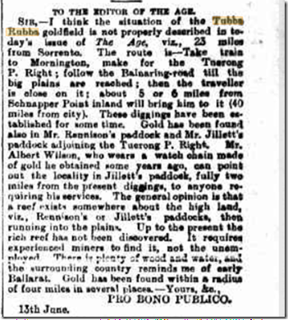

Gold, Glorious Gold – was it from Table Hill, Tubbarubbabel Creek, or creeks on Tuerong Park PR
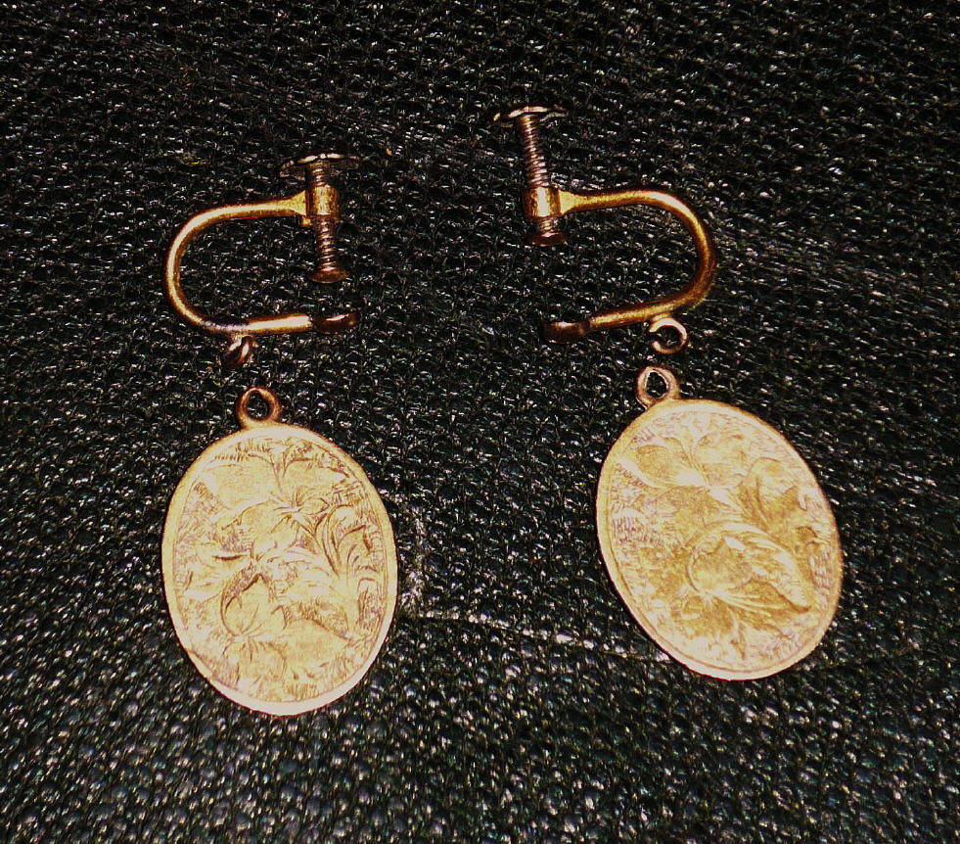
Thank you Peter Ward
Our family is indebted to our guest, Peter Ward, for his excellent programme of research which has yielded so much new understanding for us about our Wilson forebears and their Tuerong Park endeavours
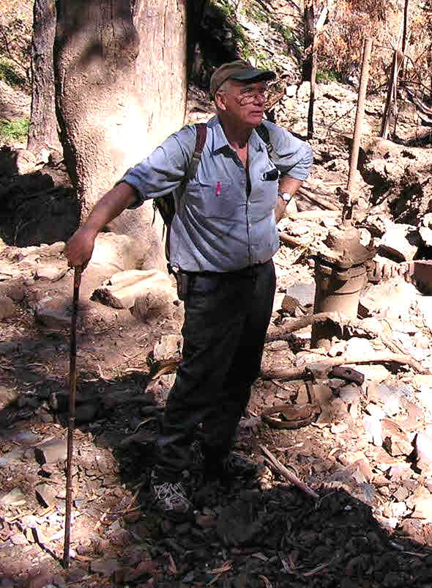

This document based primarily on the research of Mr Peter Ward: produced by Peter Ward & Laurie Wilson. February, 2017

Tuerong Park Preemptive Right – Wilsons who lived, worked, or had financially links there

John Bowman Wilson Agnes Eliza Smith McDonald William Sorell Wilson

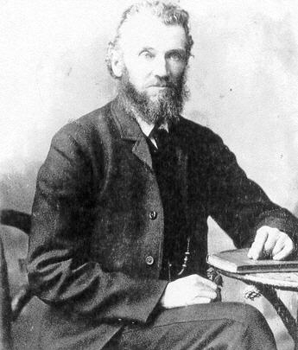
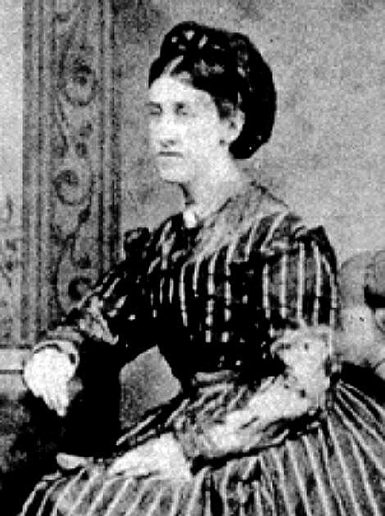

Margaret Williamson-T William McDonald-T John Frederick-T Agnes Eliza-T
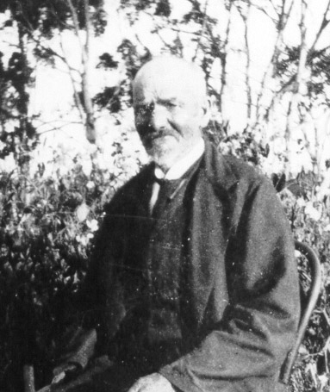
And we’ll not forget little Agnes Eliza who died of Croup aged three at the Table Hill goldfield, July 12 1859. Croup killed dozens of children on the goldfields
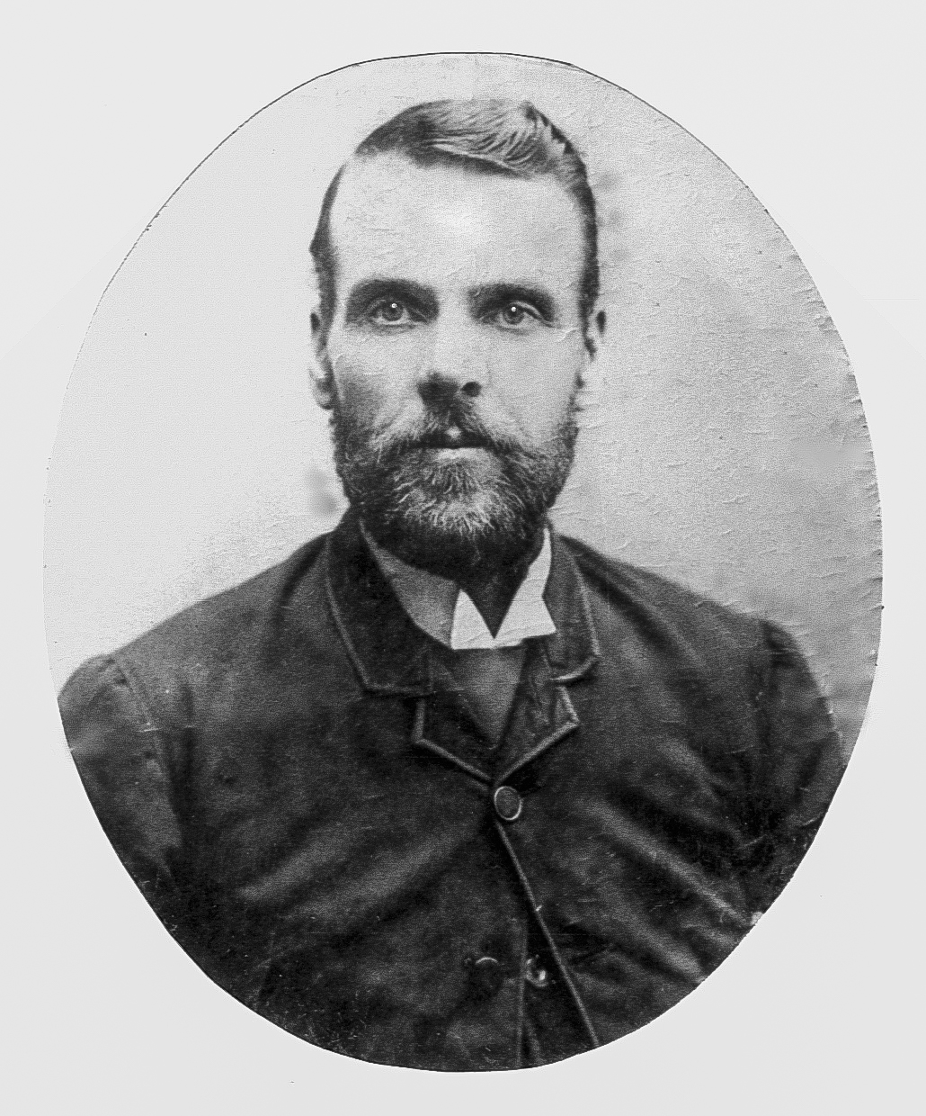
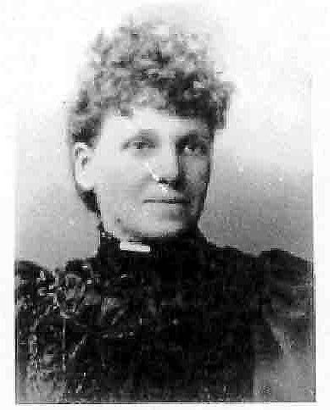

Edwin-M Albert Edward-TH Arthur-Tu Ellen-Tu
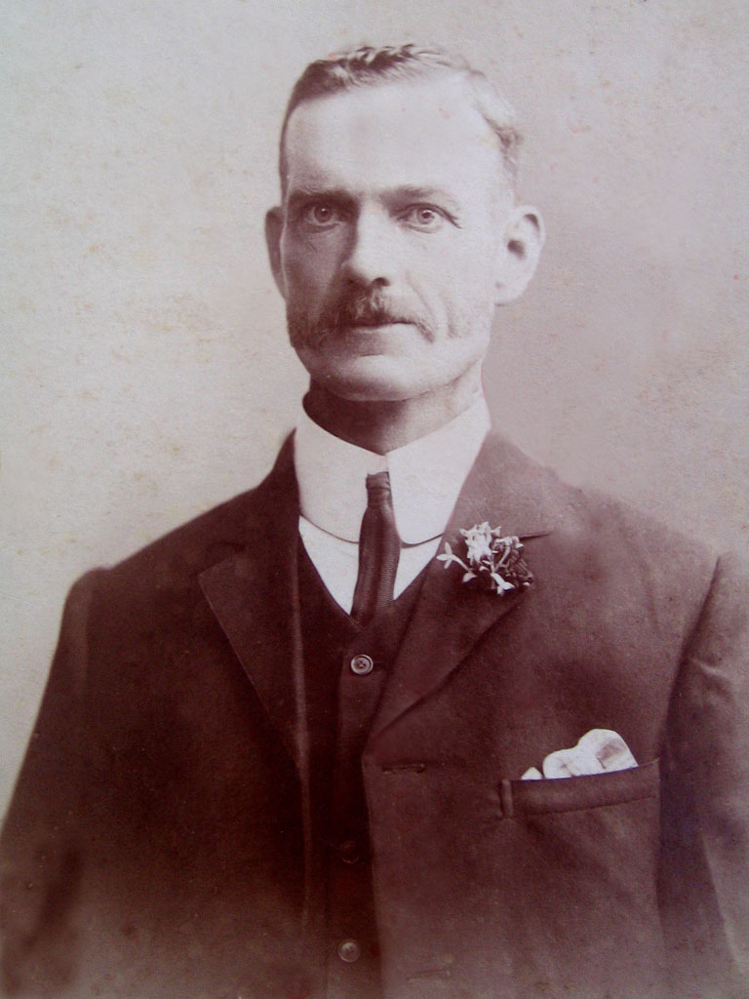
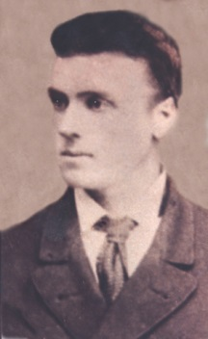
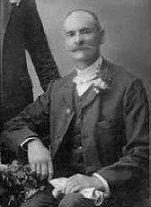
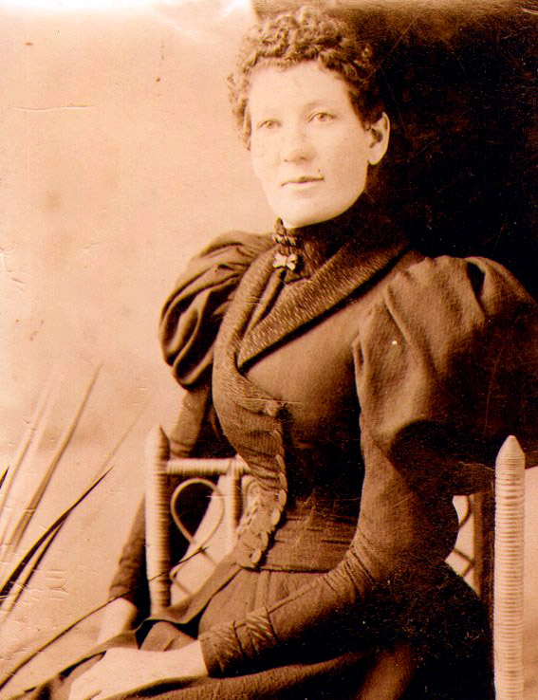

Charles-Tu Herbert-Tu Agnes-Tu
John & Agnes Eliza’s children are listed here in order of birth, with birth location marked:-
T=Tasmania
M=Melton
TH=Table Hill Tu=Tuerong
