‘The Rabbit Skins’

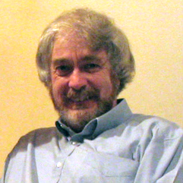
by
Mike Wilson
2017

Of course, I did not know my uncle Charlie Wilson – he died some 32 years before I was born. My first knowledge of him originated in my childhood. Gradually, I learned of a tragedy that had once beset the family and that somehow it involved a war and two brothers – Bert and Charlie.
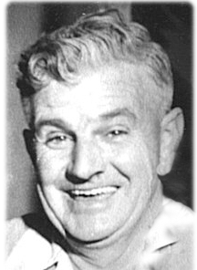
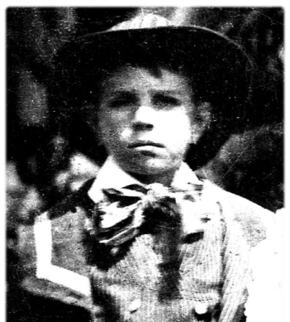
And then there was the tangible evidence of a life cut short – all locked away in a rusty metal chest that my Dad, Jim Wilson had kept, from a remote and, to me, mysterious time. Sometimes, I would be allowed (usually after my constant pleadings), to examine the contents. While there were numerous musty old papers that held no interest for me at all, I believed the real treasures were a number of brightly ribboned military medals and what I thought was a huge penny – so big that I thought it would probably buy a lifetime’s supply of ice- creams (they were only sixpence then). The penny depicted a lion, behind which was a lady in a funny hat and flowing robes, holding a wreath over a panel engraved with a name – Charles Alfred Wilson. What I didn’t know was that those
old papers that I had dismissed so
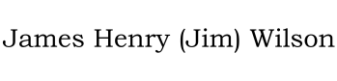
readily held a secret – one that would not be revealed until four decades later.

My Dad also had some large framed and faded photographs of two soldiers in uniform – one had a cross on his right sleeve and wore long leather boots while the other had two stripes on his shoulder and seemed to have his calves wrapped in bandages. Both wore flat military caps and appeared to be very young. These I learned were Bert and Charlie; there was always a sense of sadness when their names were mentioned.
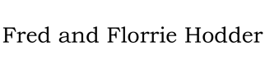
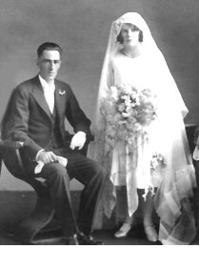
Mum, Dad and I used to regularly visit with my Auntie Florrie who lived at Broadford with her husband Fred Hodder. The house in Short street was simple and quite old, but was always suffused with the delightful aromas of Auntie’s cooking. Despite the prospect of a wonderful roast meal created on a cast iron wood stove, there was really very little to amuse a young boy from the Big City. Apart, that is, from the dilapidated and precariously leaning old shed out the back that looked as if its split slab timbers had never been painted since it was first nailed together centuries before. Inside was a workbench and cupboards, strewn with rusty old tools and discarded household items – a lifetime’s bits and pieces to be examined and explored each time we visited.

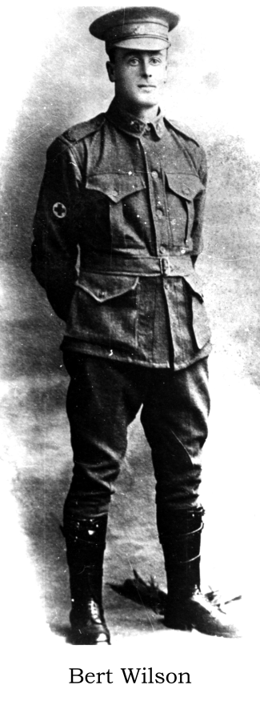
On one wall hung about twenty rusted wire frames bent into a u-shape. Stretched on each of the wires was what appeared to be a desiccated piece of leather covered in cobwebs. I asked Uncle Fred about them and he told me they had been rabbit pelts, but Fred was a very quiet man, often absorbed in his own thoughts and I learned no more. The skins were quite hairless, obviously very old and apparently quite useless for anything - I couldn’t understand why they had not been thrown away years before. Eventually, I determined to ask Dad if he knew why this should be. Immediately, as I asked, I could see the old sadness come over him, but he told me the simple tale of the rabbit skins.
When Dad was a boy, his half-brothers, Albert Edward Wilson (Bert) who was named after his father, and Charles Alfred Wilson (Charlie) joined the AIF. Charlie was inducted into the 5th re-enforcements of the 24th Infantry Battalion in 1915 (Service Number 2484) and Bert, after no less than six earlier rejections due to a hernia, into the 10th Field Ambulance in 1916 (Service Number 12435); he was 29 years old.
Charlie was born in the Victorian seaside town of Mornington on 26th March 1892 son of Albert and Ann Wilson. At age 24, he signed up for military service in WW1 on 14th July 1915 and was eventually sent to Egypt for training. However, after just 5 weeks, he collapsed during an exercise and was sent to the 1st Auxiliary Hospital at Heliopolis for treatment. He was diagnosed with mitral heart disease (probably as a result of the rheumatic fever that he had contracted 3 years earlier) and pronounced medically unfit for service. He was returned home to Australia aboard HMHS Wandilla and then discharged. Charlie was not done with the Army however for, several months later, concealing his earlier service and heart condition; he re-enlisted intending to join Bert in the Motor Transports. He was pronounced fit and was inducted to the 22nd re-enforcements of the 5th Infantry Battalion. He was given a new Service Number (6832) and the rank

of Acting Corporal for the duration of the voyage to England aboard the HMAT Ulysses and arrived in Plymouth on December 28th 1916.
Before they each joined the War, the brothers decided to go rabbit hunting, together with Jim, near the old home in Broadford one last time. They resolved to skin and tan the pelts, and sell them when the older boys returned from the war. I can imagine the pride my Dad would have felt, happily following behind his soldier brothers who were soon to be on their way to a heroic war. The rabbit hunt was successful and, while the rabbits ended up in the pot on the old wood stove, their skins were duly stretched out on wire frames and hung in the shed to dry.
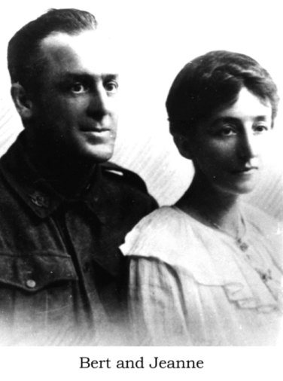
After a period of medical corps training in England, Bert served in France for the duration of the war. According to his Service Statement, he was wounded in the shoulder by shrapnel on 19/9/17 and was hospitalised for 5 months. He re-joined his unit in February the following year and after a short spell of leave to the UK, remained on active service until the Armistice. Upon his return to England in 1919, he married Jeanne Vangraschepe, a dress-maker and daughter of a Belgian police inspector from the Rouen area (where Bert had continued to serve after the cease of hostilities). The experiences of war and the sights he would have been exposed to in the Field Ambulance can undoubtedly be seen in his face in this post-war photograph with his wife.
After marrying in a London registry office on 19/8/19, they travelled together to Australia aboard the HMAT Benalla in October of that year. Bert and Jeanne subsequently lived in the Frankston area and had a daughter, Jeanne. Bert left the army in January 1920 to become a telephone linesman for the Post Master-General’s Department and although he lived until 1947, he suffered from the effects of poison gas for the rest of his life.
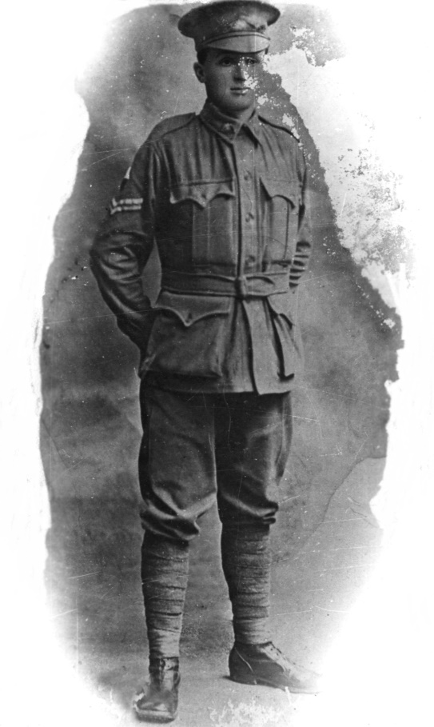
Charlie however, did not return from the War. He died in 1917, in the Fargo Military Hospital in Wiltshire, as a result of contracting pneumonia whilst training for deployment to the Western Front.
“Yes, we lost quite a few Australians that way” was the reply – I guess that is as close as it gets to an apology from the British military! With that, the desk corporal turned away to more pressing matters and I left the Larkhill Camp guardhouse in Wiltshire, England to follow his directions to the small military cemetery near the village of Durrington. For me, it proved to be an unexpectedly emotional experience - not simply as a result of finding among the many rows, the war grave of a long lost uncle, but in the sudden, heartfelt realization, that so many other families had lost sons and fathers in that awful war. Often, because of the great distance and economic reality, they could never have visited their loved ones’ last resting places or known of their final days. But there I was, in June 2001, and I had come knowing why Charlie had died before he even had a chance to face the enemy on the battlefield.
Charlie as Acting Corporal for the voyage to Plymouth
It wasn’t until I had children of my own that I discovered an interest in recording my family’s history. And it was the thought that one day I could be asked by my sons, Tristan and Adam, “Daddy, who are the people in those old photographs?” that started the quest for me. So began years of searching, reading, collating, and delving into old government and family records, to uncover the threads and fragments of so many lives. It was a voyage of discovery too - I found for instance that the original Wilsons arrived as free settlers in Van Diemen’s Land from Scotland in 1820. Great-Great Grandfather William Hartley Wilson, a stonemason, designed the Richmond Bridge in Tasmania – Australia’s oldest stone bridge. From the archives in Canberra, I obtained both Bert and Charlie’s war records - really just a dry accumulation of army facts and olive drab figures that revealed very little about their day-to-day experiences as soldiers in the Great War.
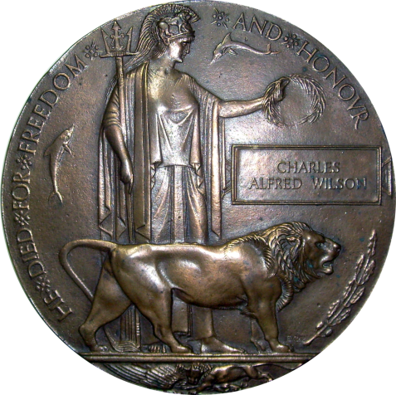
In part, Charlie’s second enlistment file read: Private Wilson, C.A., regimental number 6832 of the 22nd reinforcements, 5th Battalion, second Brigade, AIF was admitted to the Fargo Military Hospital on 14/2/1917 with pneumonia; he died five days later. The file is stamped DECEASED – he is buried Durrington cemetery 21/2/1917, grave number 205. His father Albert was sent a Memorial Plaque (the gigantic ‘penny’), a Memorial Scroll and the Pamphlet, “Where the Australians Rest” – this latter included a photograph of the grave. Three medals – the 1914/15 Star, the British War Medal and the Victory Medal, were awarded to Charlie’s family four years later.
However, it was the contents of the rusty trunk that eventually revealed some of the details of Charlie’s last months. Most of the items were the receipts of long forgotten family bills, but one tightly folded sheath of papers caught my attention. On opening, the packet contained the four pages of two letters that Charlie had written home. The words were penned on paper headed “For God, King and Empire, The Australian Y.M.C.A.” Unfortunately, all the handwriting was illegible as the paper and ink was virtually transparent, appearing to have been soaked in an oily substance at some time in the seventy years since the letters had been written. Try as I might, I could make out nothing but the printed heading and the details of Charlie’s unit.
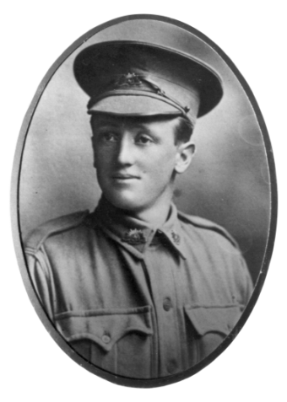
The personal computer came along just in time for me to begin assembling the family history in something approaching a professional manner. For all it’s worth however, it was not a computer that finally revealed the secret of Charlie’s early death in a military hospital far from the battlefields of the Great War. – It was a photocopier! Had I began my research in more recent times, I would probably have used a scanner in an attempt to copy the pages of Charlie’s letters. This may or may not have revealed his frozen thoughts from long ago, but as I found, quite by accident, the photocopier (with its ability, at that time, to reproduce only a limited range of tones), extracted with precise clarity the written lines from the oily paper. For the first time in many decades, Charlie’s letters could be read as if they had just been penned. The first letter (here transcribed verbatim) is dated ‘Sunday 26th November 1916’ and was written during the voyage from Melbourne aboard the HMAT Ulysses:
Dear Dad and all,
I am writing a few lines to say I am keeping well, we are now many miles from Australia, we have call in at two ports since we left & we are not allowed to tell you the names of them, the first port we call at we stopped there 4 days & I had a good look round, I sent you a post card of the city so you know it was the first port we call at, we have been having a lovely trip so far, only for two days which we got it very rough, that was two days before we call in at the first port, & the last port we call in at we only stopped there for about 8 hours. I am going to try & get transferred to Bert – that is when we land, we are not allowed to say where we are going, but I suppose you will be able to guess, I will send you a cable as soon as we land. We are getting better food on board now to what we are getting at first, we have any amount of sports on board & concert sports every Wednesday & concerts three time a week. I have met two or three chaps on this boat from Frankston. Well Dad I will write as soon as we land & I will be able to tell you more about the trip as we are not allowed to tell you the names of the ports we have call at. We get plenty of drill on board, so the days don’t seem very long, the first we call at we had three or four route marches through the city & I also met a chap by the name of [illegible] at the first port he was the chap that I enlisted with, I met him in the YMCA it was a bit of luck to strike him there as he left Melbourne three or four days before me, but I was only with him for two hours when we had to report back to boat. Well Dad I think I have said all the news that I can think of that the present. Wishing you All a Merry Xmas & a Happy New Year.
I remain Your loving son,
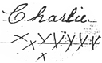

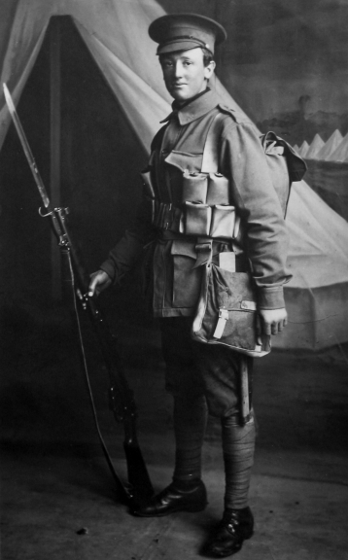
The second letter was written from the bleak Larkhill Military Camp on Salisbury Plain near Durrington during mid-winter on Saturday 3rd February 1917, it is especially poignant because 16 days later Charlie was dead:
Dear Dad and All at Home,
Just a few lines to say I am quite well up to the present, I have just come back from leave from London after four days I had a good time but if I have the luck to get another four days leave, I would not spend it in London because it is over run with soldiers, soldiers from all parts of the world, if we want to enjoy ourself it is better to get out into the country, were there is not as many soldiers. They had us on a draft to go to France last week, but we kicked up about it because they were sending us to France without any leave, so they took us off the draft & sent us on our leave to London. We have been in the camp 6 weeks now, & I have not received any letter from home yet only one from Jim, I have received two letters from Bill, & five from Nean up to the present. I am having my Photo taken over here so as soon as I get them I will send you one of them, I am not having them taken until tomorrow. I am sending by this mail views of London & I send will by the next mail views of Salisbury. I am also sending by this mail some cigars card which I have saved since I have been here they can share them up between them-self. It has been terrible cold here lately, it has been snowing & rain & we have been drilling in it without our overcoats.
Charlie at Larkhill Camp
I am going to try to get transferred into the motors transports, next week, We have had a few deaths out of this company, since we have been here, for three weeks
we average one death a week, so you can guess how bad the weather is over here. I don’t think this war will last much longer to what the papers say over here. Just about five miles from here is the (Spreading Chestnut) under which the village blacksmith stands, there is only the blacksmith shop there now.
Well Dad & all at Home I think I have said all the news at present hoping this letter will find you all in the best of health as it leaves me at present, I will now close with Love to all at Home.
I remain Your Loving Son

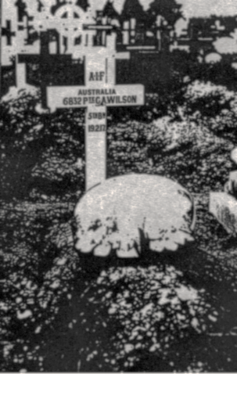
So there it is, just two weeks after writing this last letter, Charlie died of pneumonia - because he had been drilling during the depths of an English winter without an overcoat. Apparently this was a tactic used by the British Army to ‘toughen up’ colonial troops (in spite of sacrificing one life a week to this policy), but it might also have been payback for the troops having ‘kicked up’ about being sent directly to France without having had any leave. The graves of one hundred and forty one Australian soldiers can be found in the Durrington cemetery.

Charlie’s name is also inscribed on the Roll of Honour at the Canberra War Memorial and upon an obelisk opposite the Post Office in Broadford where he and his father Albert had worked as butchers. Although he never fired a shot in anger, he certainly tried to serve God, King, Empire and his Country not once, but twice!
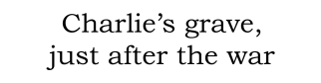

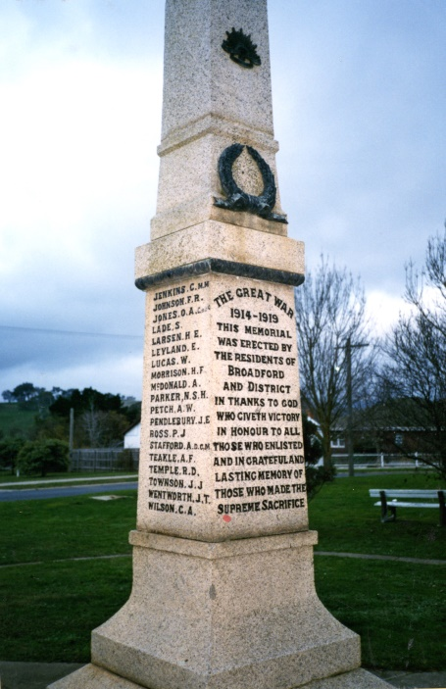
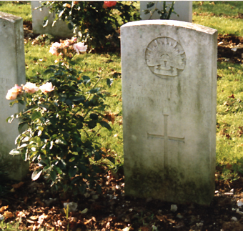
The grave in 2001
Obelisk at Broadford, Victoria

The old shed is no longer there, demolished by the new owner of the house after Auntie Florrie passed away in 1986. Gone too of course, are the rabbit skins, undoubtedly cast aside as having no worth. No worth - except as a sad reminder of the plans of three brothers separated forever from each other and all those they loved - by war and by military callousness.

- . -

