Items of Interest Related to the Ship ‘Skelton’
Reference Source – Tasmanian Immigrant Ships List
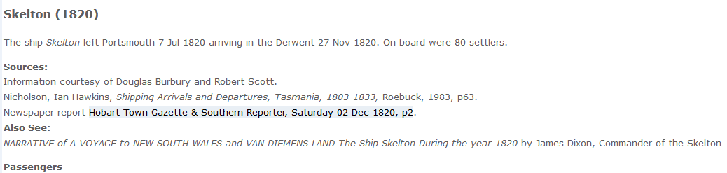
Landed in Hobart Town as per List of Passengers, Skelton
- Major McLeod, Mrs McLeod & children – Catharine, Isabella, John, Hugh, Donald | - Mr Thomas Roadnight (deceased on voyage)
- Mr David Jamieson and Mrs Jamieson & children – David & Margaret | - W. Roadnight, jun.
- Miss Jane Miller | - Herriot Roadnight & children William, Thomas, Henry & Herriot
- Mary Ann Cundell | - Mr T Roadnight jnr.
- Mr James Neil & Mrs Ann Neil &children – James, Robert & Ann | - Mr William Wilson & Mrs Margaret Wilson
- Doctor Cameron, Lady & children – Elizabeth, Donald, Robert, John & Margaret | - Mr Colin Campbell
- Captain Cummings | - Mr Donald Campbell
- Mr Samuel Haywood | - Mr Donald McDonald
- Mrs C Haywood | - Pamela Blake
- *Roderick and Ann McDonald & children – Allan, Hugh, Hector, Euphemia, Marion  Janet, Mary, Catharine, Anne & Margaret | - Mr John Headlam & Mrs Ann Headlam & children – Mary, Ellen, William, John, Charles & Fanny
- Samuel Haywood | - Mr Andrew Birrell
- Mr William Speed & Miss Speed | - Mr Alexander Waddell
- Mr Frederick Langloh and Mrs Langloh | - Mr Allan McLean
- Mr James Parker | - *Flora McLean
- Mr George Brooks | - Mr John Sanderson
- Mr David Jamieson and Mrs Jamieson & children – David & Margaret | - Mr James Haig
- John Claytown | - Mr James Anderson
- Thomas Hodgton | - Mr Thomas. Scott
- *Jenny Anderson | - James Neill
*Servants to Major McLeod

Reference Sources – Richard Weatherill, The Ancient port of Whitby and its Shipping, Bents Almanac and Hobart Town Gazette.
The ship ‘Skelton’ was built in Whitby, Yorkshire in 1812, owners were James Sons & jr and Will Dixon.
Owners in 1825 are listed as Will and James Dixon of Skelton, North Yorkshire and Mich. Trowsdale of Northallerton, North Yorkshire.
The Skelton was a 3-masted, single deck barque of 260 tons and 15 ft draft; its hull was covered and fastened with copper.
It made 2 voyages to Van Diemen’s Land, arriving on 27th November, 1820, 24th December 1822.
On July 30th 1828 under Captain Percy, whilst on a voyage from Trinidad to London, the Skelton struck an underwater rock 10 nautical miles East of Anguilla Island in the Caribbean and foundered. All aboard were rescued.

Note – James Dixon’s ship ‘Skelton’ is sometimes mistaken for the ‘Skelton Castle’ - this was another ship built by Wells in 1800 as a 3 deckker of 583 tons, it departed Portsmouth and disappeared in 1806 (British Library Records). ‘Skelton Castle ‘was also the name of James Dixon’s home in the village of Skelton in North Yorkshire. Dixon painted both his home and ship.

James Dixon | Painting - Skelton Castle farm/residence of Capt. James Dixon in Tasmania | Painting - Skelton in Trinidad or Tenerife

Reference Source – Michael Nix, A Study of Cargoes from Scotland to Australia, 1820 –1824

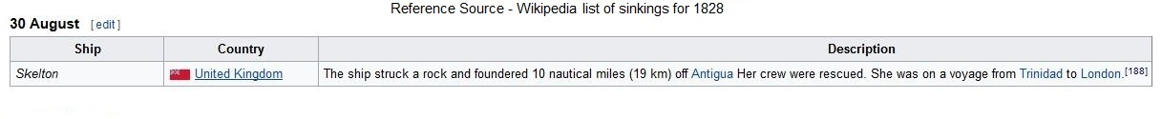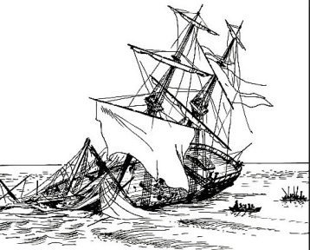

Reports in Hobart Town Gazette of Arrivals of the Skelton in Hobart Town in 1820, 1822 and 1823.
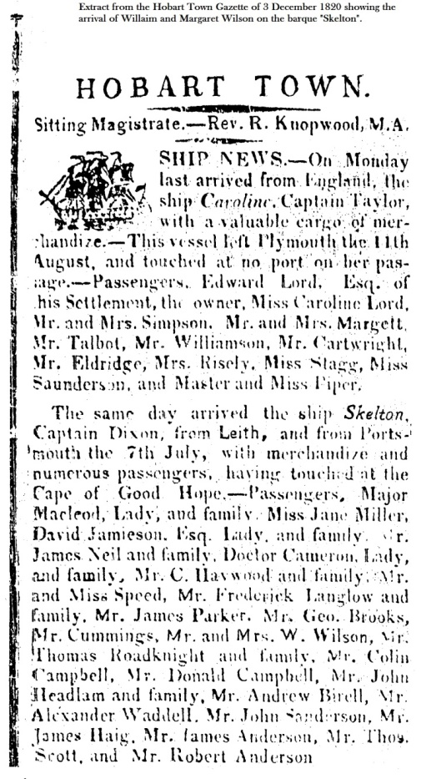 | Extract from the Hobart Town Gazette of Saturday 28 December 1822, the second voyage of the Skelton to Van Diemen’s Land.  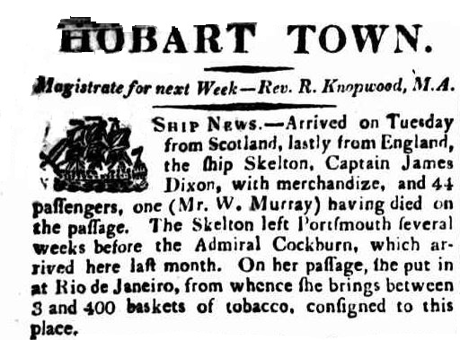  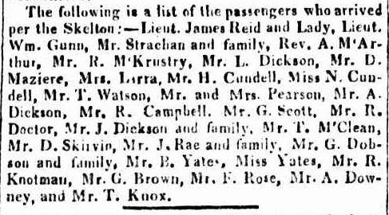 | Extract from the Hobart Town Gazette of Saturday 14 June 1823, the last voyage of the Skelton to Van Diemen’s Land.  