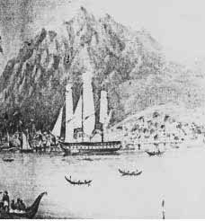 | 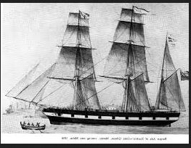
The barque “Skelton” in Trinidad harbour by James Dixon | A 260 ton barque
Background of Trinidad harbour today

