A Butcher, No Bakers, but many Papermakers
[The Papermaker Wilsons of Broadford – as Published by the Broadford & District Historical Society]
We don’t yet know what it was that first prompted my paternal grandfather, Albert Wilson to come settle in Broadford back in 1898. Did he come because of a job opportunity, or was an affair of the heartstrings the primary motivation; well perhaps both forces were at work. Whichever, he settled in this town, just as Australia was about to become a nation, working as a butcher as he did for most of his life, marrying and raising a new family of five children, all of whom were born and bred in Broadford.
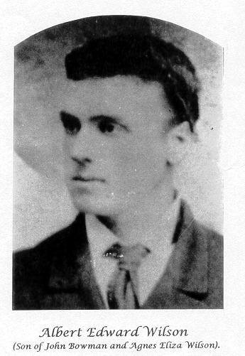
It was this ‘new’ family of siblings and in turn many from their subsequent families who were destined to become ‘papermakers’, spending their working lives in the paper industry, working with APM at its Broadford, Melbourne and Fairfield mills, and some of them later again also working at the Bowater-Scott paper mill operations in Melbourne. Probably first inspired by the presence of APM’s mill at Broadford, it is clear that all came to have ‘paper in the blood’, and continued so for life.
I say a ‘new’ family because grandfather Albert (who had died before I was born) had been previously married and had a first family of eight children by his then wife Ann Elizabeth nee Absalom, all of this family born on the Mornington Peninsula at Moorooduc. Ann suffering anemia passed on still a young woman in 1895.

Albert’s father John Bowman Wilson and his mother Agnes Eliza nee McDonald-Smith, had owned and operated a large grazing and cropping property at Tuerong near Moorooduc until losing it due to financial crash around 1890. Albert and those of his siblings who survived were brought up there. Albert was apprenticed and worked in his youth with a butcher in Mornington (Snapper Point then).
Albert was a grandson of early immigrants from near Dundee, Scotland, William Hartley Wilson & Margaret nee Williamson, who arrived in Hobart in 1820. William Hartley was appointed Superintendent of Stonemasons by Governor Sorell, and additionally filled the role of (the first) Colonial Architect of Van Diemen’s Land whilst it was still a component of the Colony of New South Wales. If you have ever crossed and admired the beautiful lines of Richmond Bridge at Richmond Tasmania, be aware William Hartley supervised its construction between 1823 to 1825 – it is the oldest bridge still in use in Australia from which we might assume William did a pretty good job of it.
Albert’s parents John, Agnes Eliza and their older children had come to the Victorian goldfields from Tasmania in 1857; Albert was born in 1861 at the Table Hill diggings near what is today Tarilta east of Guildford, south of Castlemaine. We assume his father John had some luck with the gold as he shortly afterwards in 1863/4 came to Moorooduc and with some financial help from his mother-in-law purchased the 640 acre property, which today is part of the Tuerong vinyard estate regions.
After Ann’s death and Albert’s move to Broadford the older grown up siblings of Albert’s first family stayed on living and working around the Peninsula, but several of the younger ones of this group after Albert’s 1899 remarriage came to live with their father and stepmother at Broadford – certainly William Philip aged 9, Charles aged 10, and most probably Ann aged 12.
Charles Wilson has his name inscribed on the RSL World War 1 memorial at Broadford having lost his life aged 25 in 1917 at the Fargo army training camp near Durrington, England. Charles never saw action, one of several dozen young Australians at that and other such camps who succumbed to influenza and pneumonia through exposure from rigorous training they were obliged to undergo in light summer clothing without greatcoats in English mid winter – but that’s another story.
The youngest of the first family, William Philip Wilson being closest in age to the second family siblings lived most of his growing up life with them and stayed very close to all of the second family over his long life. He was Uncle Bill to me and a man of the most pleasant personality – a genuine gentleman. Uncle Bill was the father of Richmond Football Club rover ‘Billy’ Wilson who played during the 1940s and early 50s and who today still ranks in the top twenty five goal kickers at Richmond.
Albert initially secured employment at a butcher shop in High Street, Broadford, a few properties south of the Murchison street corner, but he eventually owned this butcher shop business whilst renting the property comprising shop, house and stables from its owner, a local farmer. Later again, with his second family Albert owned and lived at another house further north on the High Street, next door to where the Sugarloaf Motel is located today.
Albert was a man who suffered much grief during his life. The loss of his first wife was clearly a major blow, but preceding that, and most traumatic for he and Ann was the loss of two of their young children at Moorooduc in 1890. Their two little boys, Frederick aged 4 and John aged 2 whilst playing on an old pram in the yard of their Moorooduc home toppled into the family’s fresh water well just behind the house; they were discovered a short time later after a frantic search, drowned. This must have been a devastating blow. But more sadness was to come with the death from illness of three month old baby son Alfred in 1895. Then Ann’s death in 1896, followed by that of his youngest brother the same year.
He had been on board a steam train in 1895 near Princes Bridge station which crashed into another with many people injured, Albert spending some time in hospital recovering. But his greatest personal escape from tragedy took place also in 1895: he played football for the Snapper Point team which one Saturday was to play against Mordialloc. He was scheduled to travel with the team by boat across the Bay to return immediately after the game.
En route home the small steamer was struck by a sudden and violent squall, turned over and sank – with the loss of all on board. Albert who had been busy working butchering and making deliveries that morning had been running late with his deliveries, his boss insisting he complete his deliveries and this fortuitously prevented him from joining the team on its ill-fated voyage. Imagine Albert’s upset at missing the boat, but then his relief at his own good fortune mingled with intense grief at his mates’ loss. There is a memorial to this tragedy (The Pelican Reef Disaster) near the beachside Mornington Park. Finally in this tale of tragic events he was to lose son Charles in England in 1817.
Albert married his second wife Frances nee Ryan (my grandmother) in 1899 at a Baptist church in St Kilda, Melbourne. They shocked the families by eloping for this purpose, Frances coming from a strict Irish-Australian catholic family who lived at East Kilmore/Clonbinane, whilst Albert was from an Anglican family; this no doubt caused considerable consternation for her family, and perhaps his too. Fortunately she still had support from at least some of her family, her brother Henry witnessing together with a lady described as a relative, a Mary Jolley, who most intriguingly is described on the certificate as a ‘lady with a wooden leg’.
The Ryan family photograph (below) was taken about 1898 outside of the Ryan’s original slab/bark home then located on Ryan’s Road just a few hundred metres west of Sunday Creek. It was one of many homes of wood-cutters then located along this stretch of road.

A well known identity in Broadford until her death in 2005 was Sheila Ryan; my grandmother Frances Ryan was an aunt to Sheila whose father Henry James Ryan is the seated gentleman in the image below. A postscript note about Sheila and the Ryans appears at the foot of this essay. Sheila lived in this cottage some years after its relocation to another site a little further along Ryans Road.
Those in this image from left to right are: The lad unidentified but possibly Robert’s son ; Frances’ younger brother Henry James Ryan b.1873; Frances Ryan b.1870 standing beside her mother Anastasia Ryan nee McCormick; Frances’ father Charles Ryan; and Frances’ older brother Robert Ryan b.1863. Outside the Ryan’s bark roof home, Ryans Road, Clonbinane, this image taken about 1897/98 shortly before Frances’ marriage.
Parts of the Ryan family’s original house still exist today in Ryan’s Road (named after the family), at East Kilmore/Clonbinane, incorporated within the pretty little homestead known as Mulberry Cottage, adjacent to Sunday Creek right beside the Ryan’s Road crossing into Clonbinane.
Frances’ father Charles was a wood cutter who worked the logging forests in the vicinity of their home, whilst her mother Anastasia nee McCormick, known around the Kilmore area as Stasha was apparently quite a lively, vivacious personality, who like most Irish lasses loved dancing and singing.
Stasha was a migrant with her family from County Kilkenny (b.1837) whilst Charles b.1828 was born in London, his parents believed to have hailed from County Clare; he initially emigrated to the Colonies in 1836 and lived in Tasmania for five years before moving to Victoria. They met in Victoria and married at Upper Plenty in 1857, Stasha’s family at the time living at Cairn Curran Station near Baringhup, her father described in official papers as ‘Gentleman’, a title the significance of which is yet to be interpreted. Her family had originally settled in Adelaide before moving over to Victoria.

Albert and Frances had five children, John Albert (Jack) b.1901, James (Jim) B.1903, Florence (Florrie) b.1905, Edwin (Ted) b.1907, and Horace (Tabs) b.1913. All did their schooling at the Broadford primary school to eighth grade, the general standard then. All four boys were destined to become ‘papermakers’, and Florrie too, in her case ‘by way of her marriage’.
Florrie married another local, Fred Hodder, at Broadford in 1930. Fred having completed his apprenticeship as a carpenter at the APM mill: he stayed with the mill all his working life and became head of the carpenters’ shop which at its peak employed 30 carpenters/apprentices.
As young teenagers the children had helped their Dad in his butchery and secured odd jobs at local farms and traders to bring in a little more income for the family. Jack Wilson had his first real job at the APM’s Broadford mill for a brief time but shortly after, around 1926/7, transferred to the company’s Melbourne Mill – this mill was located at Princes Bridge where the Concert Hall and shopping complex stands today. Jack went on to become Board Mill Superintendent at Fairfield Mill.
Coincidentally the Melbourne Mill’s nearest neighbour was Allens Sweets which was to become a commercial Broadford resident many years later.
My father Ted followed Jack, joining APM at Fairfield in 1930 where he started as a ‘Sorter’ in the converting and finishing department, by 1946 becoming a foreman in that department. In 1948 Ted Wilson joined the Bowater-Scott tissue papermaking and consumer products business at Box Hill as Production Manager, this company being the owner of the Sorbent and other well known brands of tissue products; it had actually purchased the Sorbent brand from APM when the latter withdrew for some years from the tissues sector of the industry.
Jim and Tabs (Tabs: a pet name Florrie gave him when he was born, after their Tabby cat – the name stayed with him all his life), together with their mother came down to Melbourne during the early 1930s, their father Albert having died in 1928 aged 66. They lived in Grange Road Alphington a convenient couple of hundred meters from the Fairfield mill. They both had initially worked at the Broadford mill then transferring to APM’s Fairfield mill, Tabs also as a Sorter and Jim working on one of the paper-machines. The Fairfield mill during its life has had at one time or another two paper-machines and three board-machines, and in the early days until shortly after WW2 it also had a rotary straw & rag pulper just like the one at the Broadford mill, which is now on display in High Street. Living close by I well recall the odorous nature of the process.
The papermaker vocations continued on into the next generation too; William Philip’s two other sons Keith and Charlie (footballer Billy Wilson’s brothers) worked most of their lives with Bowater-Scott as engineers; Florrie’s son William (another Billy) Hodder spent most of his working life as an electrician at APM’s Fairfield mill; Ted’s son Laurie worked for a couple of months at APM Fairfield in the technical department for work experience, later joining Bowater-Scott in technical and management roles, remaining with that company for 32 years.
Coincidentally, at one stage Bowater-Scott via its Forest Products Division, owned the wooden cable-drum manufacturing business in Broadford which supplied OLEX Cables and other cable manufacturers with drums.
So that is a brief story of the Wilson family of papermakers from Broadford. Not a single butcher to follow in their Dad’s footsteps to be found amongst them. Maybe they were more taken with the paper Dad wrapped the meat in than in the meat itself; more likely though, they were attracted to the skills, technology and opportunity of the papermaking industry as they experienced it in their time at the Broadford mill.

In this image we see standing at rear a young Tabs, his sister Florrie immediately in front of him with two of Florrie’s girlfriends on each side of her – they are unidentified; perhaps a Broadford resident reading this essay might be able to assist with identification. On Tabs’ estimated age this image dates to about 1927/28.
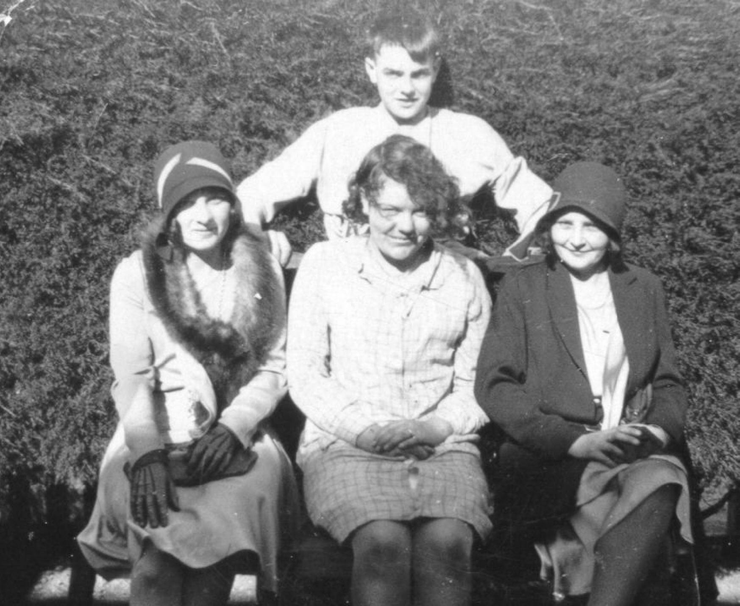

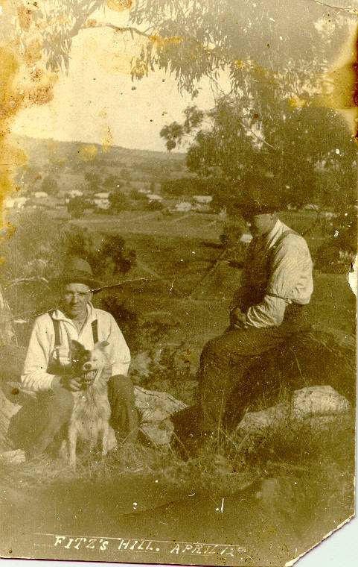
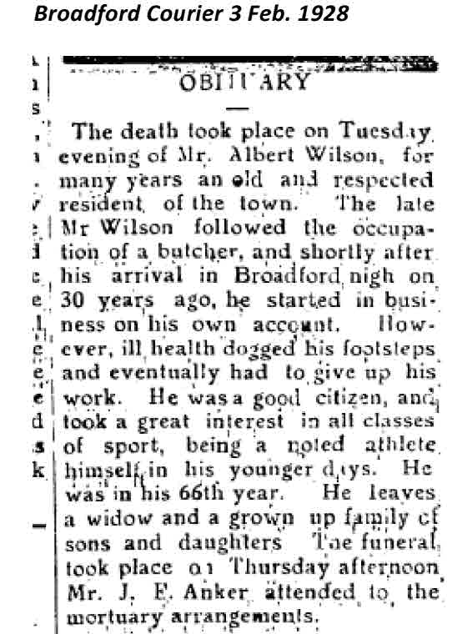

The Broadford Courier article certainly suggests that grandfather Albert was a fine upstanding citizen of Broadford, and no doubt he was precisely that. The image on the right is of Jim Wilson and dog, with Ted Wilson up on Fitz’s Hill Broadford probably April 12th, 1930. In the set of related images on the following pages we also include the re-enacted Fitz’s Hill image which took place on April 12th, 2014.
All in all a fine family as papermakers and as human beings too - with only one serious failing in their ranks with Uncle Jack who at some point was misled into becoming an ardent Magpies supporter – indeed a most avid one whom we soon learned to stay well and truly clear of when his team lost.
*******************************************
Postscript on the Ryans
Charles Ryan appears to have spent his life as a forest worker cutting wood from the extensive native forests which lay on the Glenburnie and Clonbinane Station properties, or adjoining them in State Forests. At least one of the sons, Henry, toiled as a gold miner in the area too. There were several mining ventures near Clonbinane and also at Reedy Creek.
Later generations of the family of Charles and Stasha Ryan lived in and around the Kilmore regions, at Wandong, Sunday Creek and Kilmore itself; generally their burial place is the Kilmore cemetery, however grandmother Frances and Albert are in Broadford cemetery as is Sheila Ryan. Sheila had a brother Wilfred but nothing is known of him.
I recall as a child visiting Ryan family members in all of those places back in the 1940s/1950s, and camping one time at Sunday Creek near the home of one of the Ryans, quite possibly Mulberry Cottage. Also attending the funeral of Henry Ryan, the father of Sheila, with my father in the early 1950s. Our contact with the Ryans seemed to be less frequent than it was with the Wilson side of our family all of whom lived closer in Melbourne, and as we had no car local travel was easier.
Around 1997/8 one day driving back from a visit to Wangaratta I decided to call unannounced on Sheila Ryan tracking her down with the help of some local residents. She looked at me at the front door of her home not at all sure who I was (I had not seen her since her dad’s funeral), until I said I was her cousin Ted’s son at which she invited me in for a lovely afternoon tea and a chat about family.
Tabs had long before told me the story of Sheila’s sad loss by drowning of her fiancée many years prior and I had decided I would make no mention of this knowing from Tabs something of the grief she had suffered.
To my surprise Sheila raised the tragedy and spoke quite fully about it, and mentioned her resolve from that time to remain unmarried; to be always faithful to the memory of her beloved beau. When just last year I saw the headstone at Sheila’s Broadford gravesite and the wording she had arranged to be on it, I more fully understood the lifelong grief she had born to the day of her death. Her fiancée, Spencer Horwood is interred in the grave immediately behind Sheila’s.
More recently some twelve years or so back I was contacted by a lady in California, Irene Gillis nee Jackson (known as Rene), who told me she was a descendant of Charles and Anastasia Ryan; exchange of family details confirmed that she was so descended. Irene subsequently made two visits to Melbourne and spent her time tracing and meeting her various generational cousins. This included members of another well known Irish origin Kilmore family, the Finns, from which Rene was also descended.
I was pleased to introduce Rene to various of our Ryan/Wilson connections (Tabs was still living) and take her to visit places of origin of the Ryans including visiting Mulberry Cottage where the resident Mrs Roma Newell very graciously invited us in for afternoon tea, and to see inside the house where Tabs took us to a window on which was scratched Sheila Ryan’s name – an event at which Tabs had been present as a young lad, no doubt remembering it vividly (he was well into his 80s) because of the scolding they had received. Rene was so pleased that we visited the cottage, as too was Roma our delightful hostess.
Rene is descended from a sister of my grandmother Frances, Mary Ellen Ryan; Mary Ellen had married Robert Pierce Finn and one of their grandchildren was Rene’s mother; her name was Adelaide Cyprian Finn who married Charles Jackson. Charles was an American GI stationed in Melbourne during the war. I just don’t recall now whether they married here (but I think they did) or later is USA, but after the war Adelaide was permitted to go to the States to rejoin her husband. I believe there were a few shiploads of GI War brides who went across en mass as soon as it was safe to do so.
Sadly, Adelaide who was born in 1921 had a short life, dying of cancer in California in 1954. She and Charles had five children, only three of whom survived infancy, Rene being the fourth born in 1949. In America Rene and her husband now live in Kentucky; Rene is quite a horsewoman, breeding and showing carriage horses and rigs at professional events around US and Canada.

Laurie Wilson, March 2014

