**A Note about WJT (Big) Clarke**

**Clarke emigrated from near Taunton, Somerset in the late 1850s with a significant amount of capital (about £1200), immediately investing most astutely in land and livestock – sheep, cattle, bloodstock – it seemed almost everything he touched ‘turned to gold’ in a property and livestock sense of course. But it was no mere accident of fortune; his experience in Somerset was from working in abattoirs, attending agricultural markets and stock sales where he learnt how to judge stock quality and value, and concurrently the value of land used for livestock farming and production.**

**In consequence on arriving in Tasmania he qualified for an immediate land grant because of his capital. He was noted in England and Australia as a real skinflint who saved obsessively, lived frugally and wasted nothing; but he applied himself intensively and intelligently to all that he did.**

**He proceeded thereafter to buy and sell at the right peaks and troughs of the property and livestock markets both those in Australia and England to which large components of his wool and livestock was shipped. Not surprisingly his noted meanness meant he was not the most adored man in the Colonies.**

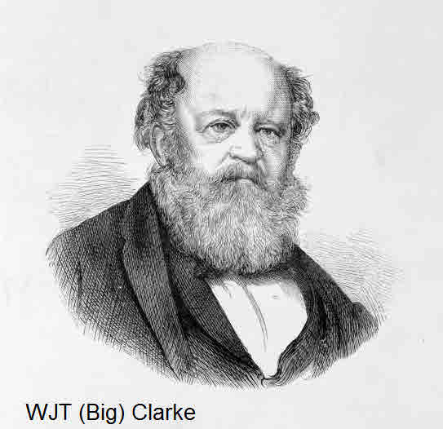

**Clarke’s rural empire grew until he owned hundreds of thousands of acres in Tasmania, Victoria, South Australia and New Zealand; he had many mansions, the main ones in Tasmania were Timsbury and Norton Mandeville, in Victoria Deanside and Rupertswood, whilst in the city of Melbourne he had Cliveden Mansion located on the corner of Clarendon Street and Wellington Parade, East Melbourne; unfortunately it was demolished early 1960s to make way for where the Hilton on the Park hotel is today.**